Online and On-Premises Solutions for Project Server 2013. An analytical comparison of a cloud solution and an on-premises solution

Table of Contents
Overview 4
Project 2013 Enhancements and Changes 5
Project Online vs. Project On-Premises. Which should I choose? 7
Key differentiators between Project Server 2013 On Line and Project Server 2013 On Premises 7
Project Online 8
What if I want to manage my own online solution is this possible? 11
What BI Features will be available in the forthcoming version of Office 365 (SharePoint Enterprise on SPO (aka plan 2)) 19
Project 2010 Exchange Task Synch to Outlook and SharePoint 2013 Task Synch 20
Considerations when upgrading to Project Online 21
What is not supported? 22
What does a Project Online Architecture look like? 22
Extranet Environments for Project Online 25
Pulling data from External Systems into a Project Online environment 25
Capacity Management for Project Online 25
Backup Restore and Disaster Recovery for Project Online 26
Operational Best Practices 26
Project Server 2013 On-Premises 27
What does an On-Premises Architecture look like? 28
Backup Restore and Disaster Recovery for Project On-Premises 39
Operational Best Practices for Project Server 2013 On-Premises 42
Planning the implementation (Checklist) 44
Review the Prerequisites: What do I need to deploy Project Server 2013 On-Premises. 44
Server Requirements 44
Client Requirements 45
Additional requirements 48
Virtualization 50
Hybrid Solutions 50
Upgrade Overview 51
Permissions Mode (Project Server and SharePoint Modes) 57
Claims Authentication 59
Appendix 60
Project Server 2013 Windows PowerShell Commands 61

Overview

This white paper provides guidance and best practices for those who are involved in a Project Server 2013 implementation. What does it take to implement Project Online as opposed to an on-premises solution? Why would I want to go with one solution over the other? The target audience consists of partners, consultants, decision makers, and technical personnel who need to understand what it takes to successfully implement Project Server 2013 in their environment, whether it be an On-Premises Solution or an Online solution with Office 365.

Project Server 2013 has introduced scenarios and components for both online and on-premises solutions. These architectural changes and their advantages are reviewed in this paper. This paper also provides information on what should be considered to successfully plan a Project Server 2013 implementation, such as SQL Server versions, Windows Server operating systems, Project Professional requirements, desktop requirements, virtualization, and extranet environments.

Best practices and strategies to successfully migrate from previous versions of Project Server 2003, 2007, and 2010 are covered. Operational excellence, including SQL Maintenance Plans and best practices around applying service packs and cumulative updates is also covered.

Backup, restore, and disaster recovery scenarios are also addressed.

By reading through this document, you will have a clear idea of the considerations and decisions that need to be made to successfully implement Project Server 2013 in your environment, whether it be online or on-premises.

Additional references to white papers and online documentation has also been provided.

Project 2013 Enhancements and Changes
Project Server 2013 has introduced a number of improvements over Project Server 2010. A Project Server 2013 Solution provides you with more flexibility and control than ever before. Take a look at some of the enhancements.

Performance Improvements:
- Multi-Tenant Support. This means that in a company you can have one department using a Project Server 2013 instance that is completely separate from other instances used by other departments. If you are hosting a solution, this makes it possible to have different companies each with their own solution. Other than the tenants sharing the use of the Project Application Service, the tenants run completely independent of and isolated from each other.
- A New Project Server Calculation Service. The Calculation Service implements the same scheduling engine that is found in Project Professional 2013, within Project Server 2013. This prevents client applications from directly accessing the Project database, while providing the same service. In other word, editing a project schedule in PWA or with another 3rd party application that uses CSOM (for example) would result in exactly the same schedule changes that Project Professional would make. For security reasons Project Server in effect hides the business objects from the clients while providing the required service. So whether you use the Project desktop or Project Server, the behavior is the same.
- Timesheets no longer use the queue service. Several significant changes here have helped improve performance.
- Self-Healing Queue Mechanism
- Reduced Page Load Time. A lot of time and effort went into reducing page load times. This applies to all pages, including the Project Center.
- Wide Area Network Improvements. A number of enhancements have been made to improve performance, especially in areas where users have latency between themselves and other locations.
- Query optimizations: Instead of routing every query through the application, Project Server 2013 now only routes queries that need to be processed. The chattiness has been reduced. The web front end business objects now communicate directly with the project database, thus providing direct business objects database queries for non-queue jobs.
- Queue Service Optimization: This has helped scalability. Queue Settings now reside at the farm level.
- Reduced number of database requests. In the past, a lot of requests were hitting the database constantly. The product team took a close look at this and asked, “Are all of these necessary?” The end result is that a lot of the chattiness (number of requests) has been reduced. If you run a SQL Profiler trace, you will notice that a lot of the chattiness is no longer present.
- Active Directory Synchronization improvements.
- At the database level: Security validation has been optimized
- At the database level: Leveraging technology from the latest SQL Server versions, there have been Data Transfer Improvements. (using table value parameters) This makes it more efficient to pass data to the databases.
- SQL Best Practices – Daily Maintenance jobs – In Central Administration a scheduled job has been created. (Help Job) This job runs a daily maintenance routine that performs key best practices, such as defragmentation.
- One ProjectServer (Project Service) database for each web application. The number of Project Server databases has been significantly reduced from four to one.
- Monitoring enhancements

Improved Functionality for Project Managers:
Tasks can now be assigned deadlines.
Formula custom fields are now updated immediately, while you are work with them in PWA.
Tasks that are Fixed Work and Effort Driven can now have full functionality.
Upgrade: The upgrade process is relatively straight forward. Meaning there is only solution, and that is the use of a Full database attach upgrade. The process will require time and planning to insure its success.
Note, there is no in place upgrade to go from 2010 to 2013. The upgrade process will require the use of duplicate hardware to successfully upgrade from Project Server 2010 to Project Server 2013.
SharePoint Lists to a Project: A simple to do list in SharePoint Server can be created. Should this to do list become more complex it can be promoted, with the click of a mouse, to a formal Project. The resource or team that was using the SharePoint list and site does not have to do anything. All of the new features are automatically enabled in the site. A field mapping tool can then be used to move special data such as a cost or a risk to a Project Server custom field.
Work Management Service: This feature will let you grab work, wherever it is managed, be it in Exchange Server, SharePoint Server, or Project Server. It aggregates tasks to a central place. Users can view and track their work and to do lists and even see them in a timeline. The tasks are cached to a person’s MySite.
Exchange can also be used to synch an out-of-office calendar. If you place an out-of-office in Outlook, the data will flow back to Project Server. Users will see that the resource is not available, and as such cannot be scheduled. All this simply by adding an event to a calendar.
Reporting: More flexibility with reporting. Do you want to see your reports on an iPad or with another browser such as Safari, Firefox, or Chrome? You can. For On-line environments the Project Service database cannot be accessed directly. OData solves this problems by acting as an interface to expose the Reporting tables and views. This interface (OData service) runs internal SQL queries against the Reporting tables and views. For on-premises customers the Reporting tables and views can be accessed through SQL Server like you have always done.
Workflow Authoring: Workflows can now be created and authored using SharePoint Designer or Visio. There is also a richer visualization of Project workflow status in Project Server.

53 Windows PowerShell commands for Project Server: To better enhance access to Project Server features and to make the application more manageable, the number of Windows PowerShell commands has been increased to 53. A list of these commands has been provided in the Appendix of the documents. Additional information on these commands and what they do can be found at http://technet.microsoft.com/en-us/library/ee890097.aspx.
Active Directory Synchronization improvements: A lot of effort has gone into reducing the amount of time required to synchronize Active Directory. Changes were made to reduce the amount of time required to synchronize Active Directory with Enterprise Resource Pools, and Project Server security groups. Some of the improvements include a Reduction in the number of RDB updates, a reduction in the number and types of jobs being run, and better timing. Meaning synchronization jobs now run during low usage periods. Active Directory synchronization jobs can now be scheduled through Central Administration.
The option to use either Project Server Permissions or SharePoint Permissions: Project Management Office’s and companies now have the ability to choose either classic mode Project Server permissions, or SharePoint Mode Permissions.
The addition of a web based mobile site: Do you have team members or project managers that need to know status or be able to make minor changes to a project plan or a document all while using their mobile devices? Well now they can.

Project Online vs. Project On-Premises. Which should I choose?
If you are looking for an environment where you do not have to worry about technical maintenance then consider a Project Online environment.
If you are looking for an environment where you can have SQL query access to the databases and where you have full control over the content then consider an On-Premises Solution.
The chart below shows some additional differentiators between Project 2013 On–Line and Project 2013 On – Premises environments.

Key differentiators between Project Server 2013 On Line and Project Server 2013 On Premises

Differentiator | On Line | On Premises
Administrative backup and restore for Projects (used to restore a slightly older version of a project without pulling a tape and impacting an entire organization) |  | x
Archival Environments to retain data |  | x
Multi-Dimensional Olap Cubes |  | x
Direct access to SQL Server Databases and OLAP Databases |  | x
Direct SQL Query Access to Project Server and SharePoint Databases |  | x
Team Foundation Server Connectivity (including 2012) (Note: The version of Project used must have the Team Foundation Server extensions installed. These extensions are not present, out of the box, in the online version.) |  | x
Standard Windows Installation (MSI) |  | x
Event Handlers can use both full trust event handlers and remote event receivers |  | x
Full access to PSI and CSOM |  | x
Access to ULS Logs  By default ULS Logs are located at C:\Program Files\Common Files\Microsoft Shared\Web Server Extensions\15\LOGS directory |  | x
As a result of full access to the databases, PSI and CSOM there is more flexibility for Business Intelligence, Dashboards, and Reports |  | x
Recycling Bin for documents, projects, and sites  Note: –Caution should be exercised when emptying the recycle bin. Once a project or a site is deleted from the recycle bin. It is deleted (gone) and cannot be recovered. | x | x
Project Web Applications (Add applications to PWA) | x | x
SharePoint Permission Mode or ProjectServer Permission Mode | x | x
Monitoring Enhancements | x | x
SharePoint Designer for workflows | x | x
No database administration | x
Security handled by Microsoft | x
Latest and greatest service packs and cumulative updates | x
Click-to-run installation | x
No direct access to SQL Server and OLAP Databases (Reporting is done via OData) | x
Access using CSOM (Note: PSI interfaces do not support O- Authentication) | x
Event Handlers require remote event receivers | x
Extensibility is accomplished via the use of the SharePoint Extensibility Model – (as a result there is no full-trust code) | x

Project Online
Project Server 2013 online was released as part of Office 365. The online version of Project 365 is designed to let project managers and decision makers focus on the required day to day project management, resource management, demand management, and portfolio management tasks. Project Online removes the burden of day to day IT tasks, such as system maintenance and database maintenance. For those companies who have limited IT budgets, security concerns, and who would like to know if Project Online is right for them, consider the following advantages:
Easy Access: Executives, portfolio managers, project managers, project resources, team members, and stakeholders will be able to access the Project Online system from anywhere provided an internet connection can be accessed. Project Online can be accessed from multi browsers and multi platforms.
Easy Installation: Project Professional 2013 (Online version) can be up and running within minutes. To accomplish this Microsoft uses Click-to-run technology. Click-to-run is a streaming and virtualization application that installs quickly and enables you start using a product before it has finished installing. With traditional MSI (Windows based installations) you have to wait until the entire application is installed, before it can be used. Click-to-run solves this problem by streaming the application. If during the installation process you try to use a feature or capability that has not yet been downloaded, the Click-to-run technology will immediately stream, download, and install that feature so that it can be used. Did I mention it was fast?
Share Project Data With Applications: Are you looking for ways to enhance your project capabilities? Do you want to enhance your online capabilities, then take a look at the free and low cost applications that are currently available in the Microsoft Project App Store http://office.microsoft.com/en-us/store/apps-for-project-FX103441147.aspx
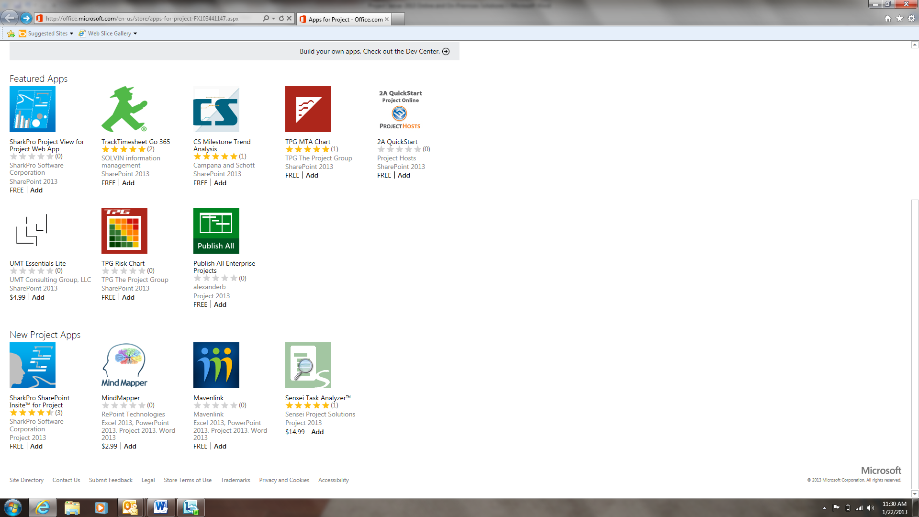
Project Portfolio Management in the cloud: Project Online contains all of the key scenarios that one would expect from an On-premises solution. Included in the Project Online solution are Demand Management, Resource Management, Time Management, Financial Management, collaboration and social. What does this mean for you as the consumer? A safe online environment that can be used to help determine which projects need to be done, and by whom. For example, a budget of x amount and yet only a limited number of resources and a specific timeframe. The online solution can be used to help determine which projects have priority and where and what needs to be focused on. The same online environment can also be used to help determine which projects are consuming the most time and resources. Ironically the use of Project Portfolio Management in the cloud can free up resources for use elsewhere, thus acting as a cost savings.
Evergreen Service: Worried about staying up to date with licenses and the current versions of software? Then worry no more. Project Online insures that you will always have the latest and greatest versions of software. It will always have the latest and greatest version of PPM, and that can include Exchange Server, Lync, SharePoint Server, Project, Office, and all of their required updates and patches. Microsoft handles it all for you. There is no need to continually purchase physical servers and keep them patched and up to date.
Operational Maintenance: The burden of day to day system maintenance, database maintenance, updates, service packs, internet explorer (browser) upgrades. Disaster recovery, and more is handled via a Project Online service which is hosted in a secure Microsoft datacenter. Microsoft insures that Project Online infrastructure has the latest and greatest set of patches and updates applied. There is no more worry about making arrangements with IT and planning for downtime while a service pack or maintenance patch upgrade occurs. Additionally preventative maintenance scripts are periodically run on the databases in order to prevent problems before they occur.
No upfront infrastructure costs: Project Online does not have any required upfront infrastructure costs. Customers do not have to purchase servers, or worry about Windows Server, SQL Server, or other server licenses. Users are on a simple, per use, licensing basis. Additional costs are not charged for disaster recovery and other database maintenance costs, and day to day operations.
International: Currently Project Online is available in 88 countries and regions and 32 languages. Resources can access their data from almost anywhere in the globe, provided of course they have access to a decent internet connection.
Continual Uptime: Looking for 24 x 7 uptime. This is it! Project Online is so secure Microsoft is willing to provide a financially backed guaranteed uptime with 24 x 7 support. Continual support where and when you need it.
Increased Productivity: How many times have you had last minute changes occur, or been traveling, and needed to make immediate updates to projects, or had to return to the office to process some last minute changes? Project on demand changes all of this. With Project on demand, there is an option to install Project on multiple PC’s, including home. Changes can even be made in the air (provided of course wi-fi) is present. Additionally integration with Office 365 and Lync online will permit you to send instant messages and kick off instant conversations, directly from your project.
Windows Azure and Business Intelligence: Windows Azure is Microsoft’s cloud platform. Currently key components of Windows Azure are in the process of being implemented in the cloud. What this means is that most recent versions of SQL Server Analysis Services and SQL Server Reporting Services will soon be available for Business Intelligence and online reporting directly from the cloud. Imagine instant access to reports and data, anytime and anywhere. 24 x 7 access whether you are traveling, away from the office, working from the comfort of your home, or simply checking on the state of your projects.
Security: Worried about disaster recovery, security, backups and or privacy? Project Online uses an Office 365 service to provide a globally redundant back up system. Additionally online customers have the benefit of knowing that they are protected by Microsoft security. This helps protect online customers against, viruses, spam, bots, and other malware. Additionally for Project Online and Office 365 customers, Microsoft provides a financially backed, guaranteed uptime with 24 x 7 support, that has been validated by a third party EPA. This is support and security 24 hours a day, seven days a week.
For more information please see the following links:
http://www.microsoft.com/en-us/office365/independently-verified.aspx
http://www.microsoft.com/en-us/office365/trust-center.aspx

Who is using the Microsoft Cloud and Office 365 for their Online Solutions? Below are a handful of documented examples:
State of Minnesota IT Department: http://www.zdnet.com/minnesota-it-bolstered-cross-agency-collaboration-with-microsoft-office-365-7000008449/
Environmental Protection Agency (EPA): http://www.globalfoundationservices.com/blog.aspx
From the same press release:
The Federal Aviation Administration
The United States Department of Agriculture
VINCI PLC (One of the world top facilities management and construction groups) http://blogs.office.com/b/microsoft_office_365_blog/archive/2012/10/10/global-construction-company-vinci-switches-off-google-apps-and-turns-on-office-365.aspx
The United States Department of Veteran Affairs: http://blogs.office.com/b/microsoft_office_365_blog/archive/2012/11/13/office-365-government-customer-va.aspx
The Recovery and Transparency Accountability Board (RATB):
http://blogs.office.com/b/microsoft_office_365_blog/
The Barilla Group: A key player and major Italian Food Companies who is also a leader in the pasta market.
http://blogs.office.com/b/microsoft_office_365_blog/archive/2012/11/27/office-365-customer-barilla.aspx
What if I want to manage my own online solution is this possible?
The answer is yes. The slide below shows what is possible and what can be done where.
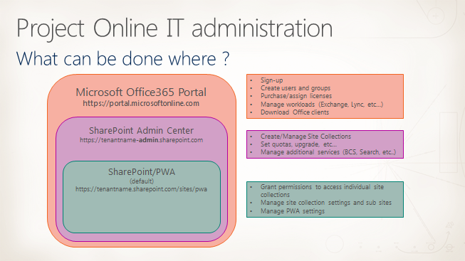

There are three basic layers of administration. All have a specific purpose.
The first layer, the Portal Admin, is where you sign up, creates users and groups, handle licensing, and download Office clients. Additionally you can use your own domain name if you have one already. If not you can go to a domain registrar, purchase one, and then add it to Office 365. Your own domain in Office 365. If you do not have a domain name or care to purchase one, then you can use the default name that is provided by Office 365.
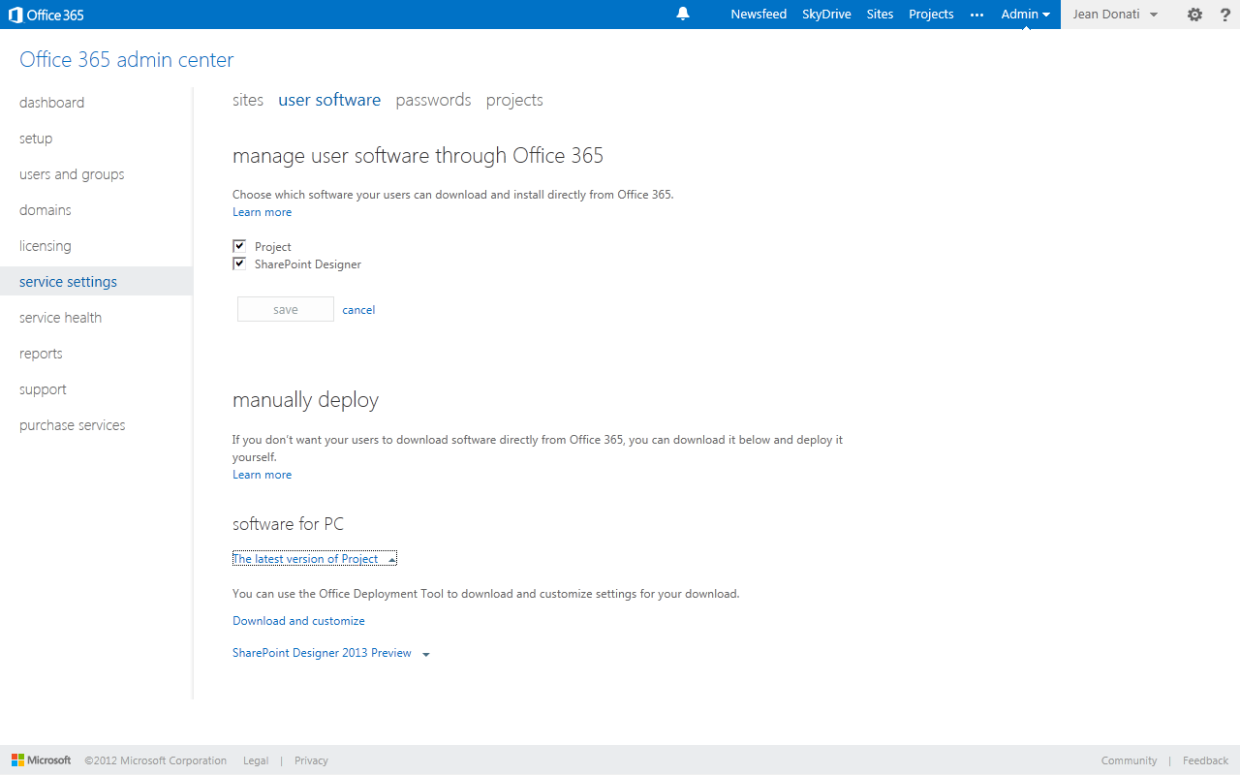
Screenshot showing the option to Manage Software by either permitting users to download the latest version of the software themselves or if you do want users to download software, you can download and deploy it yourself.

The second layer is the SharePoint Admin Center. This is where Site Collections are created and managed, quotas set, and additional services such as Search are managed from.
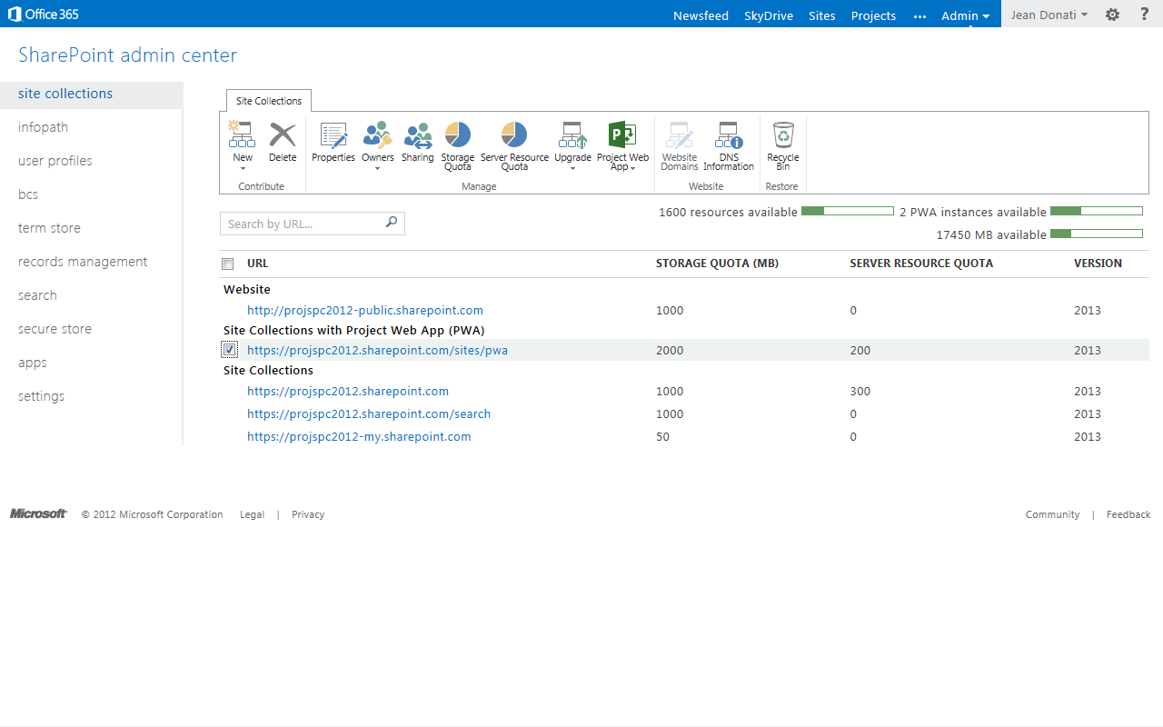
Screenshot showing SharePoint Admin Center with two instances of PWA available.

The third layer is SharePoint/PWA online. Here you can manage PWA settings, manage site collection settings, and grant permissions to access individual site collections.
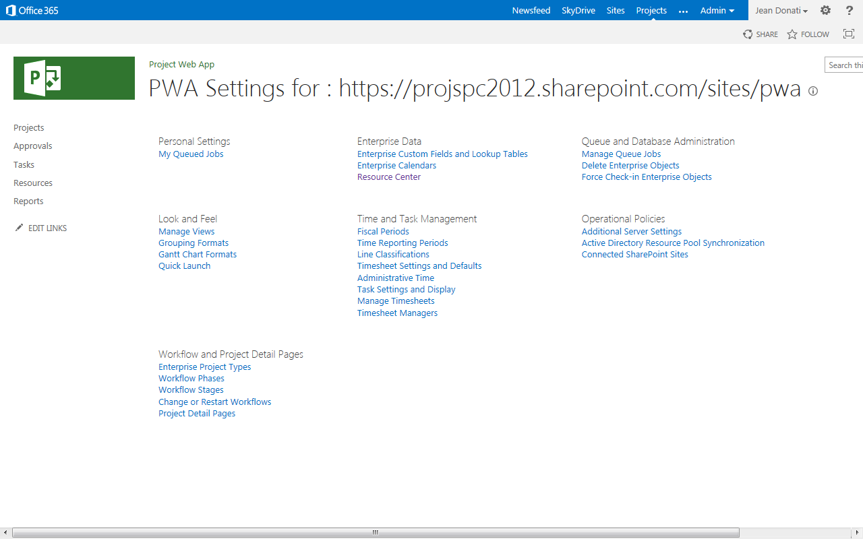Screenshot showing PWA Settings
Another questions that frequently arises is:
What options are available to use if I want to manage my own servers in an online environment? The answer is Infrastructure as a Service (IaaS). Project Online is Software as a Service (SaaS). In May of 2012 Azure Virtual Machine (VM) was disclosed as an upcoming offer. This option provides the ability to purchase CPU, memory, and storage in a cloud, from which a virtualized environment containing SharePoint Server, Project Server, or other applications can be run. In Azure VM you and or your resources are responsible for managing the operating system, (this includes updating and patching it). You are also responsible for the installation and configuration of any and all applications (that is, Project Server 2013 and SharePoint Server 2013.) Currently SharePoint Server 2010 and Project Server 2010 are supported. In the near future both Project Server 2013 and SharePoint Server 2013 will be supported.
The real question is:
Do you want to be in the business of managing server and applications in:
1. Your own environment (On – Premises)
2. Have Microsoft manage your servers and applications in an online environment (Project Online) or
3. Something in between? (Infrastructure as a Service)
The diagram below illustrates the differences between the three.
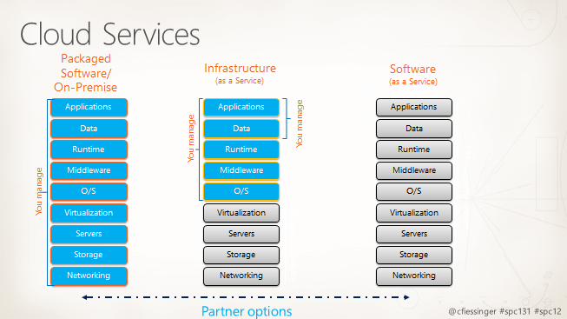
The following diagram, kindly provided by Christophe Fiessinger, shows the difference between an On-Premises Solution where you own, manage, and control everything, versus Infrastructure as a Service (IaaS) where Microsoft provides the storage, networking, and virtualized servers, and you manage the servers, or a full Project On-Line environment where Microsoft assumes the risk for everything infrastructure-wise and you manage your applications.
Reporting Online and Business Intelligence
Office 365 and Project Online making reporting simple. All that is required is time phased data, powerview and an ODataOData connection to create SSRS Reports. Timesheets Reports at all levels (including custom fields), Reports on every Project by workflow stages, portfolio planner and optimizer data, and much more can easily be accomplished through the use of time phased data , PowerView, and an OData connection.
There are two main data sources for Reporting
- Relational Reporting Database
- Multi-dimensional OLAP Database(s) (On-Premises Only)
For comparative purposes, to illustrate some of the differences and similarities between On Line and On Premises reporting capabilities, please reference the table below.
Business Intelligence & Reporting Tools | On Line | On Premise | Notes
Relational Reporting Database (Project Service) | x | x | Reporting Table accessible via OData feed. See Note 1 & Note 3
Multi-Dimensional Olap Database(s) |  | x | On-Premises feature only
SharePoint Business Intelligence Center | x | x | By default this is provisioned inside the project web application (out of the box) See Note 4
Excel | X | X | Simply provide the users with the correct connection string and they can build the reports they want
Excel Services | X | X | Produces Reports on the server See Note 5
Powerview | X | X | New component within Excel 2013 that can be used for reporting
Excel 2010 with Power Pivot Add – In | X | X | Excel 2010 cannot be used to report through the OData service. See Note 3 and Note 5
Visio, Visio Services | X | X | Ideal for visualizing processes and showing the state (health) of the above processes.
Performance Point Services | X | X | Allows powerful dashboards which you can filter and permits interaction between individual web parts
SQL Reporting Services | X | X | A very popular report building tool. With SQL Reporting Services 2012 Sp1 it is now possible to view and interact with reports on iOS devices. For more information see http://msdn.microsoft.com/en-us/library/jj659023.aspx
New Reports (including Burn-down) | X | X | Available for both versions
Time-Phased data | X | X | On Line and On Premises
Non Time-Phased Data |  | X | On Premises Only (Multi-Dimensional Olap Cube) & Non-Time Phased data can also be used for Summary Reporting
Note 1: All four Project Server databases (Archive, Published, Draft, and Reporting) have been combined into a single database. In the past only one of the four databases, the Reporting Database, had its schema exposed. In Project Server 2013 the default name of the database is ProjectService. The single 2013 database is designed so that existing reports, etc. will continue to work. Each of the databases has a set of tables that corresponds to one of the previous four databases. While direct access to the Draft, Pub, and Ver (Version) tables is not supported, the Reporting table data and views have been exposed as an OData feed, additionally the reporting table and views have kept their same names. What this means is that old reports that pulled data from the old Reporting Database should continue to work. For further reference, the schema for the Reporting Table of the Project Service data is available in the SDK.
Note 2: On Premises Reporting requires that the data be time-phased.
Note 3: Reporting through the OData service, for both On Line and On-Premises solutions, requires Excel 2013.
Note 4: Note four is a summary obtained from http://technet.microsoft.com/en-us/library/ff603998 This summary and the aforementioned link provide additional information on the SharePoint BI Center and Reporting. For more information please see the link above.
The SharePoint Business Intelligence Center is a subsite of 2013’s PWA site (Project Web App site). As such it inherits its permissions directly from PWA. This site can be especially useful for providing reports to users in the organization and to others who may not be directly associated with or have assignments in a given project, such as Executives and Stakeholders.
Should it become necessary to provide users access to PWA reports (without providing them direct access to the main Project Web App site) you can do one of the following:
- Break the permission inheritance between the SharePoint Business Intelligence Center and the main Project Web App site. The advantage to doing this is users can then be added directly to the SharePoint Business Intelligence Site without providing them access to the Project Web Application Site. The disadvantage is you or someone you designate will have to manually keep track of and manage permissions for users who require access to both sites.
- Create a site in the same site collection as Project Web App, albeit with different permissions, and then deploy dashboard pages to that site to make the needed reports available.
The following diagram shows the available SharePoint Server 2013 groups and site permission levels along with whether or not the permission levels have access to OData feeds. These groups can be used to provide users with permissions to access Reports, Report Templates, and Office Data Connections. It if becomes necessary to secure specific items within the SharePoint Business Intelligence Site, such as a specific report or if you need to restrict access to a report folder or an Office Data Connection, security permissions can be customized (on an exception basis) by either creating a new security group or by editing existing security permissions.
Project Web App Group | Permission Level | Access to O-Data Feed
Administrators | Full Control | Yes
Portfolio Managers | Design | Yes
Portfolio Views | Design | Yes
Project Managers | Read | No
Resource Managers | Read | No
Team Leads | No Access | No
Team Members | No Access | No

Note 5: Project Web App data (for reporting) is only accessible via OData. This OData feed must be accessed via Excel 2013. It is important to note that while OData reports can be published to the SharePoint Business Intelligence Center and even displayed using Excel Services, the data cannot be refreshed using Excel Services.

What BI Features will be available in the forthcoming version of Office 365 (SharePoint Enterprise on SPO (aka plan 2))
Upcoming BI Features
Excel services as part of SPO can open Excel files that contain tabular models in them and allow full interaction with the Excel content
The Excel files can contain Power View sheets that use the tabular model embedded in Excel as their source
Restrictions and Limitations
The files can be up to 10MB in size. This size allow for 1-1.5 Million rows of data in the largest table in a model that is optimized for space. If you want to learn how to optimize tabular models (In Excel or in AS) you can read this whitepaper
All refresh need to be done on the client side (Except some limited refresh scenarios like refreshing from data which sits in Excel tables and is modified during the session). It means that in order to see new data you need to refresh on the client and upload the file again to SPO
Who can use this feature and when?
The features described are part of SharePoint Enterprise on SPO (AKA plan2
The easiest way to see for yourself is to enter https://microsoft.sharepoint.com and ask for a new site for you or your team. This tenant is ready to use these features today. You have to login as <yourusername>@microsoft.com
For an external user they can go to www.microsoft.office.com/preview and ask for a preview tenant with SharePoint Enterprise.
Existing users of O365 that already have plan 2 should be able to use this features by end of February.
Project 2010 Exchange Task Synch to Outlook and SharePoint 2013 Task Synch
Yes it is true, the Project 2010 task synch to Outlook has been deprecated. However, the integration between Project Server and Outlook for task integration has been replaced with a feature known as SharePoint 2013 task synch. This feature is actually an enhancement since it provides the same functionality albeit with a lot less effort on the part of system administrators. In previous versions of Project, Project 2010 for example, in order to enable the Project Server to Exchange to Outlook synch, Exchange administrator’s had to make changes to each users Exchange profile. This required authorization and the need for cooperation from an Exchange administrator. Certainly not a model for self-sufficiency. In some cases Project Server administrators were left without a solution.
How is the SharePoint 2013 task synch feature an improvement? Simple. Since early versions of SharePoint Server, users have been able to synch a SharePoint list or lists and document libraries with Outlook. This is similar. Here users will simply choose to synch their Project Server task assignments with Outlook, and then will be able to report on status like they did in 2010. This same feature will also permit users to synch with tasks from other SharePoint task lists.
Below is a diagram showing how this is accomplished with the use of Office 365
- Select the Tasks tab.
  - Inside the tasks tab select Tasks in the left hand pane
- On the far right side, click connect to Outlook
- Synch tasks with Microsoft Outlook. Be sure to select the Synch tasks button. It won’t auto select. Click ok. The synch will kick off.
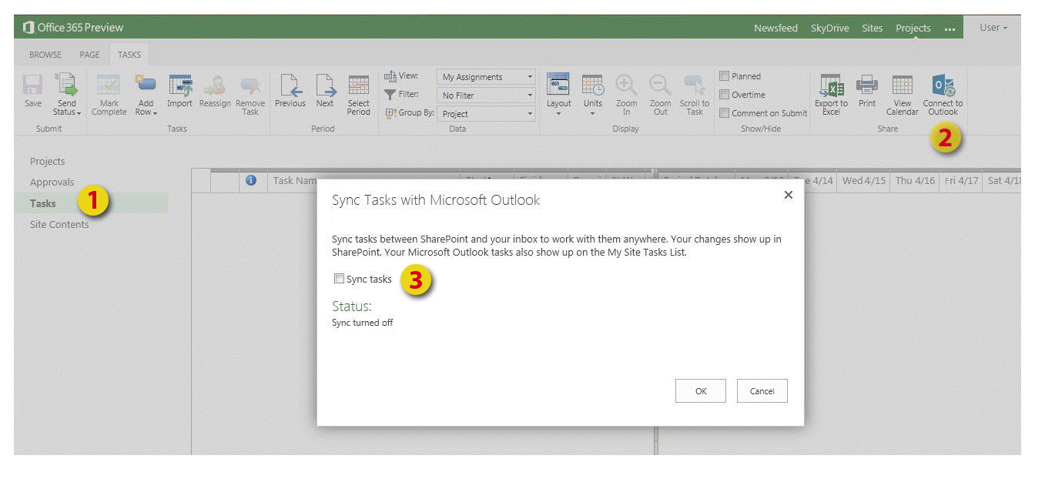

Considerations when upgrading to Project Online
Moving to Office 365 (Project Online) will require either a manual move or the use of a third party tool such as Fluent Pro. Some automation is possible with the use of vba. The reason for this is that there is no data upgrade to project online. Hence the need for either a manual move, some vba automation, or a 3rd party tool. For additional information on migrating your data to Office 365 (Project Online) with Fluent Pro, please see the white paper written by Emmanuel Fadullon.
When migrating from SharePoint Server (2007 and 2010) to SharePoint Online (Office 365) the most common solutions are Metalogix, Quest, and MetaVis. Other options are also available.
[Note Microsoft does not endorse one product over another, these options are provided as a courtesy, and are strictly for reference purposes only]
For manual files, the upgrade process is straight forward. You can open a Project 2003, 2007, or 2010 file and then import it into Project Online. No Client upgrade is necessary.
For custom fields, either copy and paste them or have someone manually recreate them in the Project Online environment.
In addition to projects and custom fields the following kinds of data can be migrated manually:
Resources
Calendars
Security Groups
Security Categories
Olap (except for multi-dimensional cubes which are currently on-premises only)
EPT’s
PDP’s
Timesheet Settings
Event Handlers
Views, dashboards, workflows, and reports will need to be manually recreated since any connections which they may have previously had will no longer work.
Please note: Project Online will require a connection to an Exchange Online solution.
Hybrid Solutions using either Project Online with a local on premises exchange solution or an On-Premises Project Solution with an Online Exchange Solution are not supported.
Project Server Sites and their content will also need to be migrated to the SharePoint Online environment.
Note: While SharePoint tasks lists can be used to share your project data with other users, care should be exercised when using this feature, the reason being, one of the primary purposes of Project Management is to track, across an organization or company, what projects users are working on along with their progress. If a project or series of projects are created through the use of SharePoint task lists, in addition to the their normal Project assignments, resource data, costs, and reporting can become skewed since by default SharePoint task lists do not share their data directly with Project. What this means is that, unless resources are part of PWA, out of the box SharePoint task lists do not inform Project Server that your resources are assigned to other Projects, and as such are not being tracked by Project Server. It is therefore vital that this information be imported into Project Server. Doing so, will give resource managers, portfolio managers, executives, and others insight into what is happening across their companies.
What is not supported?
A hybrid solution where Project Online is integrated with an On-Premises Exchange Solution.
The reverse is also not supported.
A hybrid solution where Project On-Premises is integrated with Exchange Online. Project Online is an Office 365 Solution that will be integrated with Exchange Online.

What does a Project Online Architecture look like?

Project Server 2013 is based on SharePoint Server 2013. The diagram below shows both on premises and online applications. For an Online Solution there would be an additional layer of security provided by Microsoft’s Data Centers.
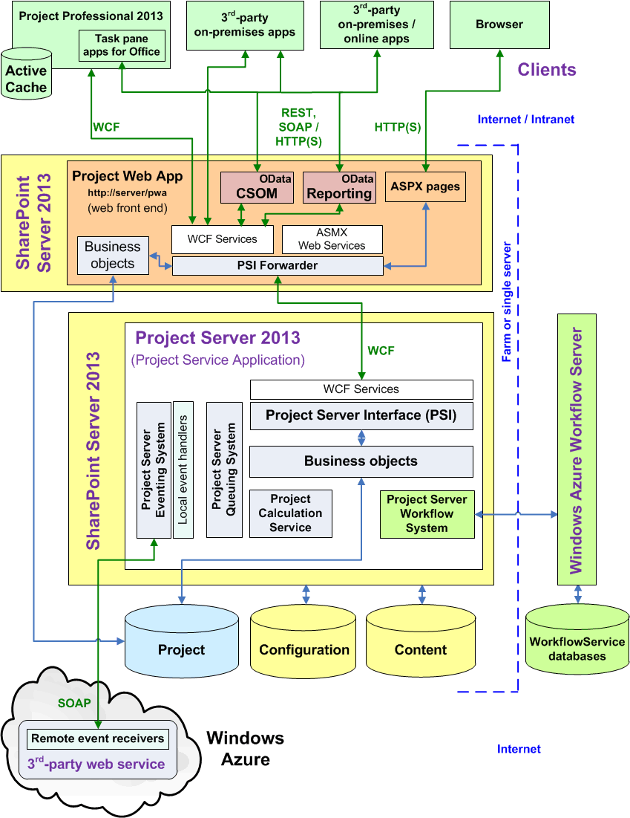Project Server 2013 Diagram
The next diagram shows which portions of the online architecture are not directly accessible via code.

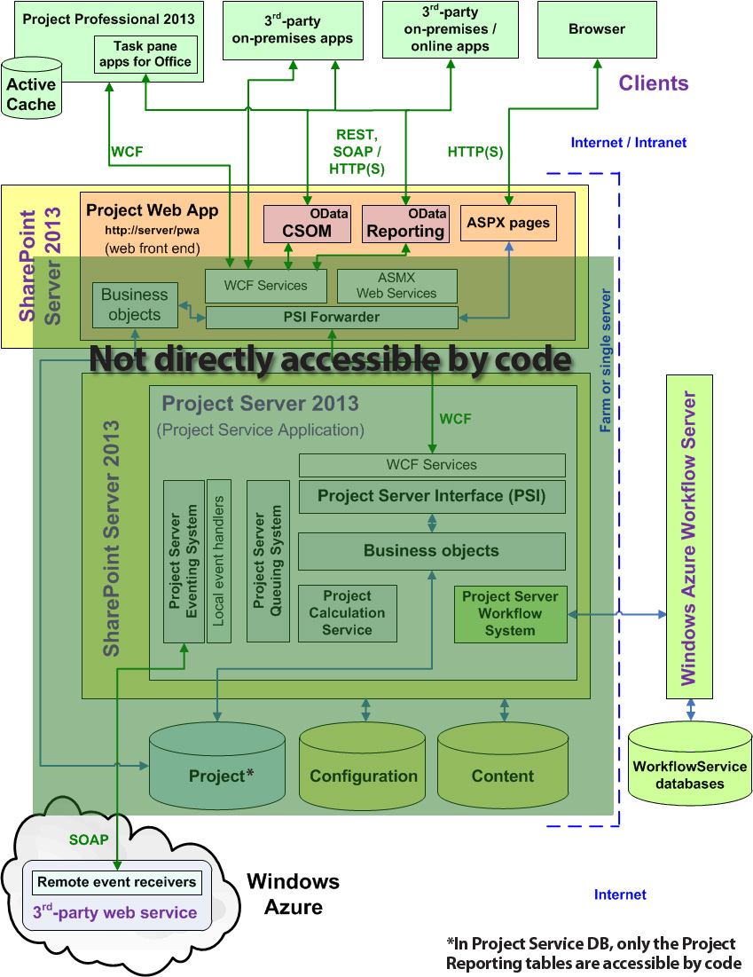Not accessible via code

Extranet Environments for Project Online
Project Server 2013 runs as a service in SharePoint Server 2013. What this means is that Project Server 2013 uses the same architectural criteria that SharePoint Server 2013 uses. In the case of Extranet users and an Online Solution any extranet users would need to be added, as users, to the Exchange Online environment. They could then connect with the permissions that you have assigned to them, the same as any other user. This is an advantage to using Project Online.

Pulling data from External Systems into a Project Online environment
Yes, this can also be accomplished. A common question is how would Project Server, in the cloud, be able to pull in external data? Eg. Financial data, project costs, and or resource costs. Is there a mechanism to import this data into the Project Server Online system instead of having users re-key the data into Project Server via the UI?
The answer to both of these questions is Yes. It is the same solution used by an On-Premises Solution. It is accomplished via the CSOM and OData interfaces. Use of the CSOM and OData interfaces will permit the data to be pushed and or imported into the Project Server online environment. Microsoft Engineering recently did a demonstration where they connected to SAP. For more information on connecting to outside data sources and details on how they did it, please see Stephen Haden’s paper and Emmanuel Fadullon’s paper.

Capacity Management for Project Online
For Project Server 2013 Online, users require a subscription in order to login. The designated tenant (site) administrator for your company or group is in control and responsible for the number of users. Based on the number of users, infrastructure requirements are automatically taken care of for you. There is no more guess work as to how many servers and what types are needed.
Question: Are there any added restrictions on the number of users you can add or that can log in at a given time?
Answer: This is one of the advantages to using Project Online. Microsoft handles the load for you. Your subscription determines the number of users. It is similar to the on premises solution in that there are no added restriction to the number of users that does not hold true for an on premises solution.

Question: Are there size restrictions on documents?
Answer: Documents are handled by quota size for the site collection.

Question: How many PWA instances can I have with Project Online?
Answer: A tenancy can have up to three PWA instances. This can be seen within the tenant administrative UI.

Question: In Project Server / SharePoint Server 2013 Can a non-standard PWA site become a PWA site or vice versa? Can a PWA site become a SharePoint site?
Answer: In 2013 A site collection is created that contains the Project Server bits. Once this site collection is created and provisioned you will be able to create sites and subsites that will know how to be PWA like, however the site collection will first need to be provisioned this way. If the site is not provisioned with the PWA bits it will not know how to behave. With a Project On-Line Solution the PWA sites are already correctly provisioned for you and as such know how to behave.

Backup Restore and Disaster Recovery for Project Online

A key advantage to using the Project Server 2013 Online solution is that Disaster Recovery is handled by the service and organizations should not have to concern themselves with it.
If a document or a PWA site is mistakenly deleted it will automatically go to the recycling bin, where it can be recovered it needed.
Note 1: If the recycling bin has been cleared then the document or site will not be available.

Note 2: Projects can only be handled by the PWA Administrator. If these are deleted, they cannot be recovered.
Note 3: Administrative Backup and Restore is not available in a Project Online environment. If multiple versions of a Project are needed, for any reason, the best option is to identify the project(s) and save the required versions manually. Keep a backup copy stored locally.

Archival Environments: Occasionally customers have a legal requirement to keep project data, financial data, resource data, legal, and other information for many years after a project has been closed. In such situations a separate dedicated Archival Environment is warranted. Archival environments are currently not available out of the box, for Online environments. As such any required archival environments would need to be setup using on-premises, solution.
Alternatively it would be possible to build or contract with a third party development company to build a custom solution. For example, a provider hosted application that uses a remote event receiver to copy published project data to a SQL Azure Store, or copy published projects to a local Project Server instance.

Operational Best Practices
Another key advantage to using Project Online is that many of the Operational Best Practices are taken care of. For example:
- Database backups: Handled by the Microsoft data center.
- Database logs: Handled by the Microsoft data center. No need to worry about large transaction logs and or having your database run out of space due to transaction logs being to large.
- Temp DB issues. Handled by the Microsoft data center.
- SQL Maintenance Plans. Handled by the Microsoft data center.
- Service Packs and Cumulative Updates are guaranteed to be up to date. There is no need to schedule service pack and cumulative updates with your IT staff and or worry about down time while the SharePoint Wizard is being run.
- SharePoint Central Administration. Handled by the Microsoft data center.
- Server Health. Handled by the Microsoft data center.

As can be seen the key day to day maintenance is handled by the data center. This frees up IT staff to work on other projects.

Project Server 2013 On-Premises
A Project Server 2013 On-Premises Solution provides you with more flexibility and control than ever before. In terms of the actual look and feel, Project On-Premises and Project On-Line look and feel the same. There are some differences. For example, Project On-Premises has menus and features that are not found in the On-Line version. These menus provide access to back end items that the On-Line version does not. Items such as SharePoint Central Administration, access to OLAP Cubes, ULS Logs, and direct access to the databases, and servers. On-Premises gives you control, access, maintenance, and flexibility. With On-Premises Solutions all of the menus are accessible. Additionally there is more flexibility in terms of creating and building reports, working with Olap Cubes, and setting up internal maintenance tasks and jobs, since direct database access is possible.
On-Premises only menus include:
SharePoint Central Administration:
Queue and Database Administration:
Olap Database Management
Daily Schedule Backup
Administrative Backup
Administrative Restore
Operational Policies:
Alerts and Reminders
Server Side Event Handlers
Project Site Provisioning Settings
Bulk Update Connected SharePoint Sites
Workflow:
Project Workflow Settings
Same look and feel as Project Online
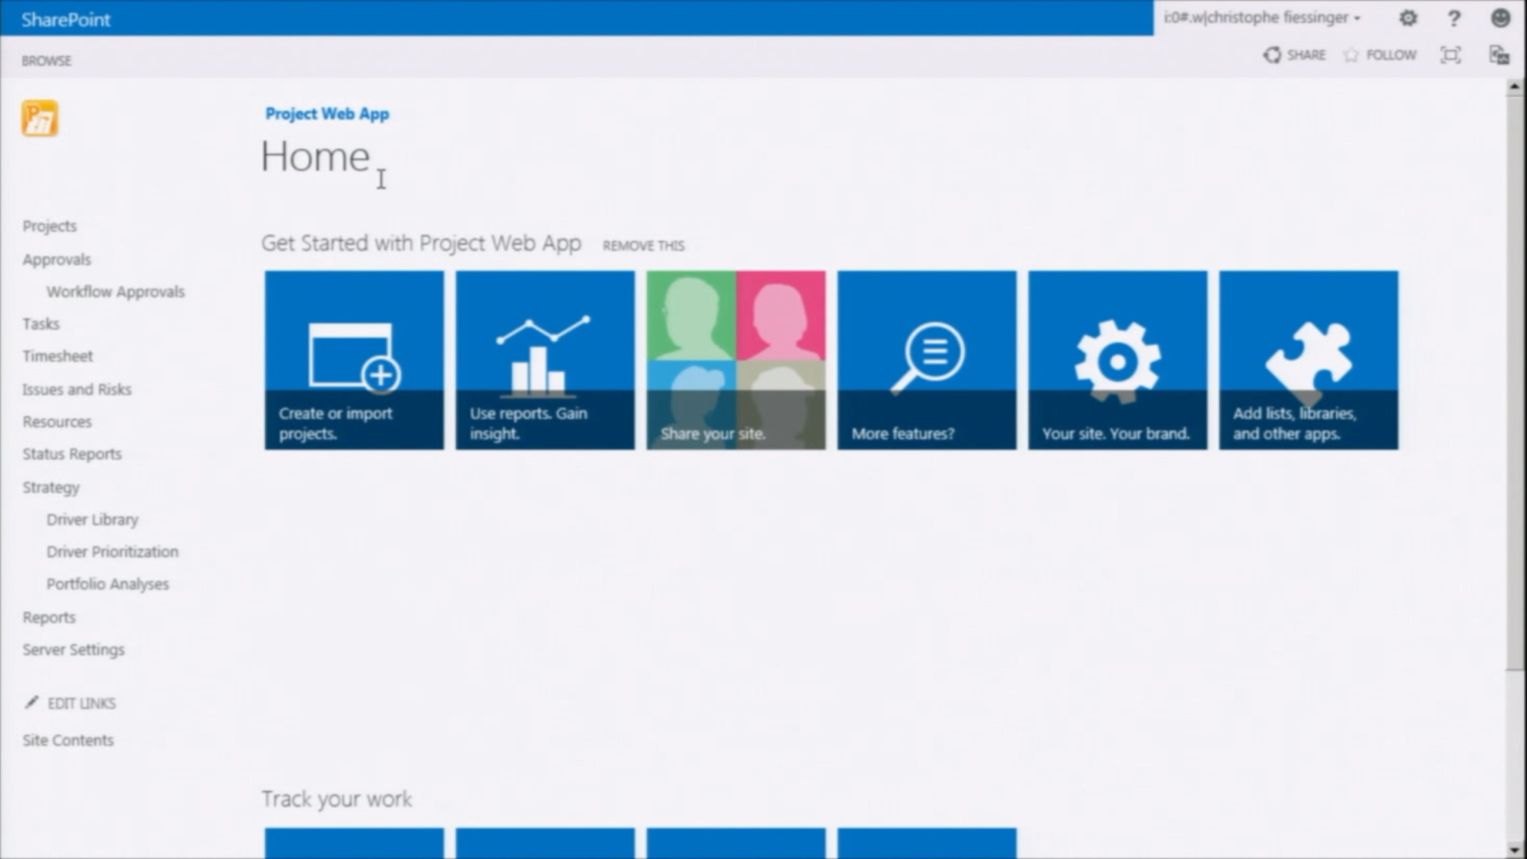
Snapshot showing PWA On-Premises Solution
PWA On-Premises has the same look and feel as Project On-Line. What this means is that it is the same Project Server, you can add lists, libraries, and other applications. You can do everything you can do online and more. One of the key differentiators of an On-Premises solution is that you have direct access to the databases, access to OLAP Cubes, and more control and responsibility.
Reporting: More flexibility with reporting. Data does not need to be time-phased and unlike the online solution where no direct access is provided to the SQL or OLAP Databases, here you have full control. Do you want to see your reports on an iPad or with another browser such as Safari, Firefox, or Chrome? You can.

What does an On-Premises Architecture look like?

Project Server 2013 is based on SharePoint Server 2013. The diagrams below shows both on premises and online applications. For an On Premises Solution there would be an additional layer of security provided by your Data Centers.
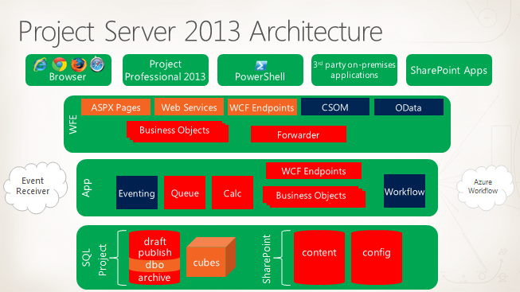
Project Server 2013 Diagram
Extranet Environments for Project Server 2013 On-Premises Solutions
Project Server 2013 runs as a service in SharePoint Server 2013. What this means is that Project Server 2013 uses the same architectural criteria that SharePoint Server 2013 uses.
Capacity Management for a Project Server 2013 On-Premises Solution.

This section provides insight into Capacity Management for Project Server 2013 On Premises Solutions. For more information please see the Project Server 2013 capacity planning document located at http://technet.microsoft.com/en-us/library/ff646967.aspx
Ideally when planning for load/capacity management it is a good idea to plan for and to project needs for several years out.
When considering what to plan for, there are many factors which influence hardware configuration as well as capacity management. Some of these factors include the following:
- User Profile: There are several types of users ranging from real people to Interface Feeds simulating what a real person would perform as well as the Project Server threading model on how many queue operation to run concurrently in the back end processing data. The various user profiles place stress on the web front end, application server as well as SQL Server depending on the operation being performed.
- Feature Usage/Workload: The type of workflow and features used change the performance characteristics of the system. Usage profiles can change the design on all tiers of the solution.
- Data Profile: The type of data being used has one of the largest effects on performance for hardware sizing. Usage of the different types of core and metadata objects can affect the sizing considerations.
- Scalar Depth: The data profile has a direct relationship to data depth. For example, changing project durations from 2 years to 5 years can add ~14 million rows to the database. Adding 5 more assignments to a task can increase web front end CPU cycles by 40% and for task custom fields add the total assignment custom field count by 100,000 rows for a single project. With 5000 projects this may begin to have an adverse effect on the proposed sizing guidelines. To keep performance optimized on a Project Server system requires a frequent SQL Server maintenance plan as well as a detailed data retention process to keep only applicable fiscal data in the operational store.
- Multi-Tenancy: The coexistence of other applications that compete for system resources such as SharePoint search/indexing on the application tier.
- Virtualization: A key note to the virtualized environments is to understand where system contention may affect response times comparable to the physical servers. Typical areas to watch for are:
- Physical container characteristics
- Disk IO on the virtualized file
- Number of logical CPUs
- Logical memory allocation
- Virtual memory address space
- System resource contention across shared applications
- Workstations: Another aspect of hardware sizing, that is often overlooked, is the client machine running Project Professional and Project Web Access. A lot of performance issues are related directly to the client machine configuration with underpowered CPU, Memory and resource contention across multiple applications open at the same time. Multi Level Undo, Master Projects using auto-calculations across multiple subprojects other features tend to use more memory and as such can be resource intensive.

The following diagrams show some examples of what is possible for small, medium, and large datasets. Below are the recommended minimum requirements for:

- A small dataset consisting of two servers. A dedicated computer running Project Server, SharePoint Server, SQL Server, and SQL Server Analysis Services, with a dedicated computer running Reporting Services.
- A diagram showing the recommended minimum requirements for a small dataset consisting of a single front end web server, a dedicated computer running Reporting Services, and dedicated SQL Server fail-over environment
- A diagram showing the recommended minimum requirements for a medium dataset consisting of a single front end web server, an application server, a dedicated computer running Reporting Servicesand a dedicated SQL Server fail-over environment
- A diagram showing the recommended minimum requirements for a medium dataset consisting of two front end web servers, an application server, a dedicated computer running Reporting Services and a dedicated SQL Server fail-over environment
- A diagram showing the recommended minimum requirements for a large dataset consisting of four front end web servers, two application servers, a dedicated computer running Reporting Services and a dedicated SQL Server fail-over environment.
Windows Note: Either Windows Server 2008 R2 Sp1 (or higher) or Windows Server 2012 can be used with Project Server 2013.
SQL Note: While either SQL Server 2008 R2 or SQL Server 2012 can be used for SQL Server it is NOT recommended that these be mixed. For example, if SQL Server 2012 is used then SQL Server 2012 should also be used for SQL Analysis Services, and both should be service packed to the same level.
SQL Note 2: When installing or setting up your SQL Servers consider using a SQL Alias.
SQL Note 3: When designing your own systems pay special attention to the SQL subsystem. This is just as important, as a fast server with lots of RAM. The RAID configuration, drive speed, and splitting out of databases onto SAN LUNS and spindles can have a significant impact, and will affect performance.
SQL Reporting and BI Note: For those desiring or wanting to use either Power Pivot or SQL Server Reporting Services for reporting purposes, the BI (Business Intelligence) edition of SQL Server 2012 or the Enterprise Edition of SQL 2012 will be required. The Business Intelligence Edition adds the PowerPivot and SQL Server Reporting Services capabilities to the Standard Edition. A few additional optimizations to the BI stack are also available. The SQL 2012 Enterprise Edition provides all of the same features as the Business Intelligence Edition. In addition it contains all of the whistles and bells that are required to ensure a highly scalable deployment.
For more information on what PowerPivot can do and to see some sample videos please see the following link: http://www.microsoft.com/en-us/bi/powerpivot.aspx
While not depicted in any of the diagrams below, PowerPivot, if used, should have its own dedicated server. This server can be resource intensive.

Note: Sizing requirements will vary from customer to customer since load patterns and business requirements can vary greatly. These slides are provided for reference purposes only. Actual requirements will vary. For medium size and large size customer deployments consider splitting of SQL Server Analysis Services onto its own dedicated physical machine. SQL Server Analysis Services is a fairly intensive process. One that goes through every single project, resource, and custom field. Ideally Analysis Services should not be run during normal business hours, to avoid placing unnecessary load on the servers during those hours.
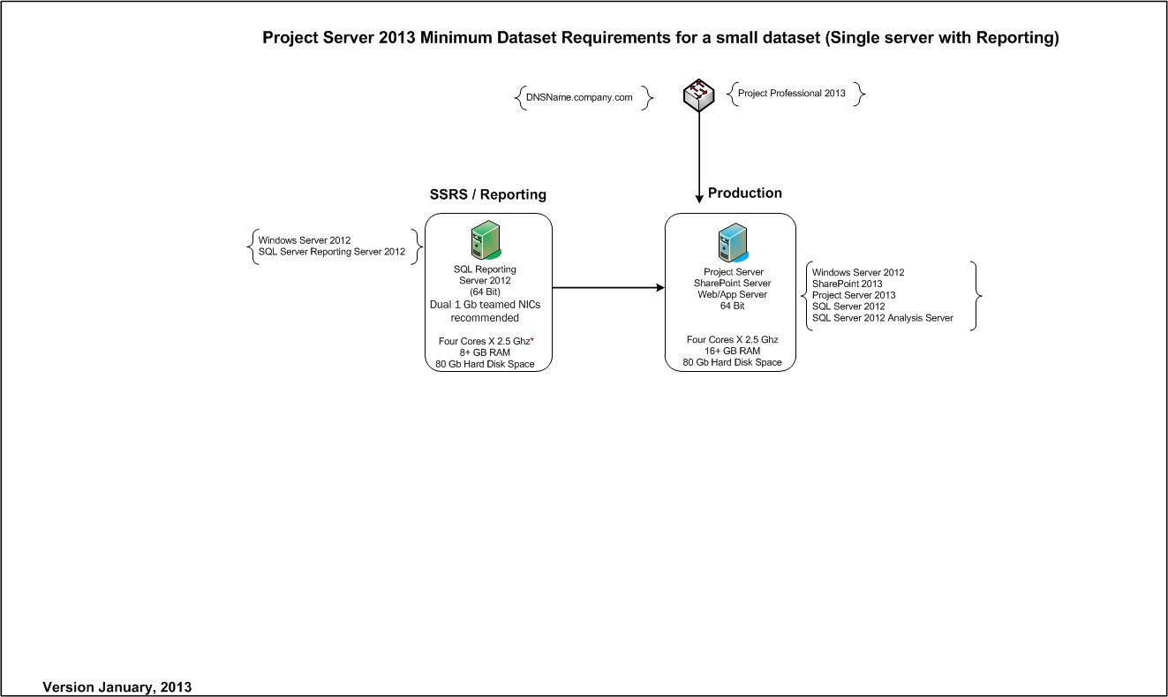
Diagram showing recommended Minimum requirements for a small environment consisting of a single server and a dedicated server running Reporting Services

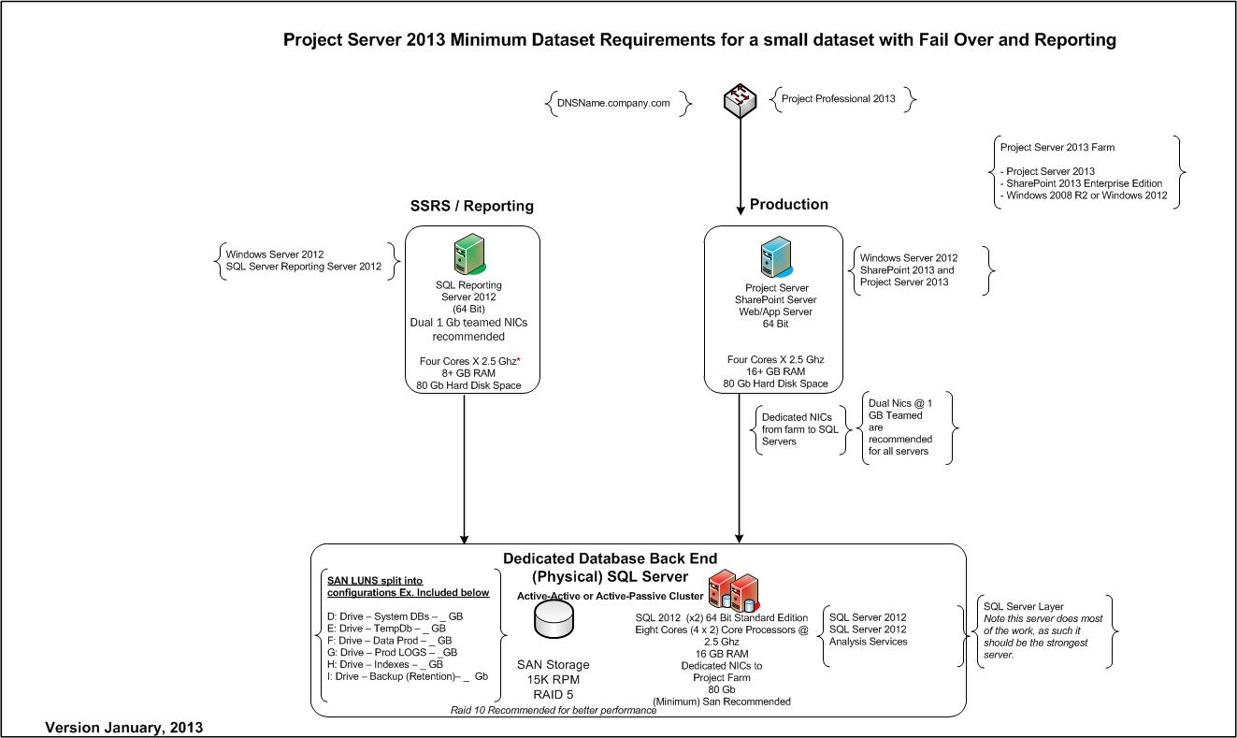
Diagram showing recommended Minimum requirements for a small dataset consisting of a single front end server, a dedicated server running Reporting Servcies, and dedicated SQL Server fail over environment
Note how the System Databases, Logs, Indexes, etc. have been placed onto separate physical hard disks

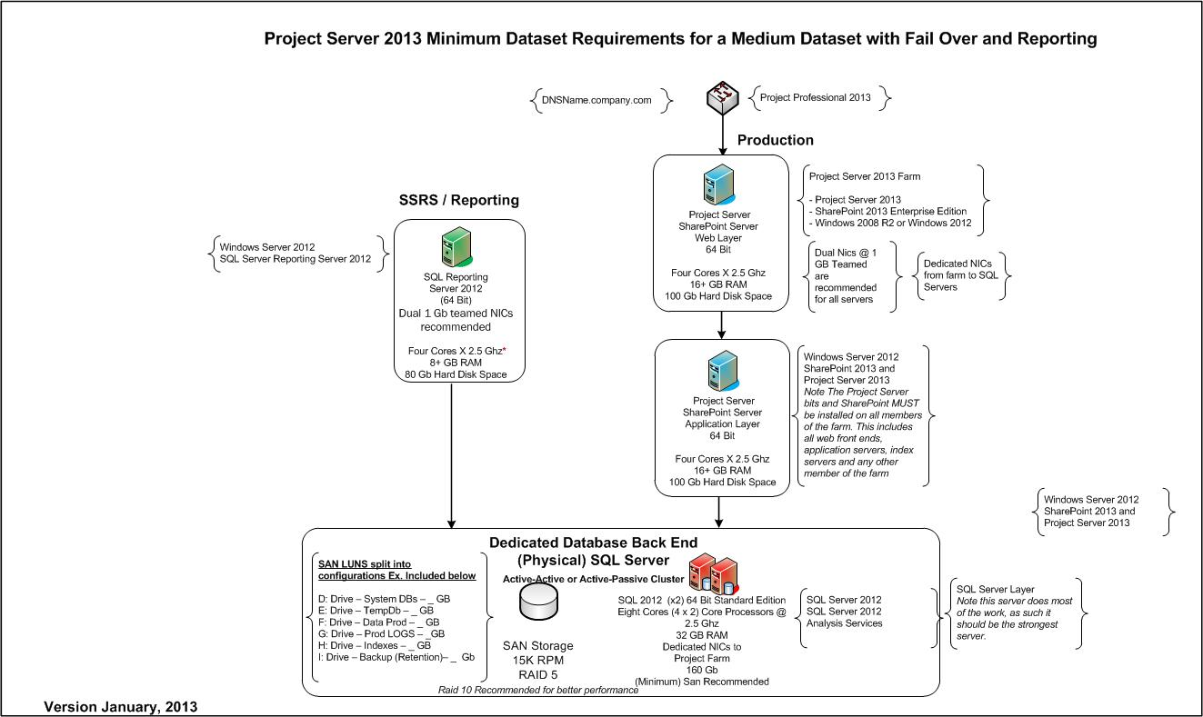
Diagram showing recommended Minimum requirements for a Medium Dataset consisting of a single front end web server, a single application server, a dedicated server running Reporting Services and a dedicated SQL Server fail-over environment
Note how the System Databases, Logs, Indexes, etc. have been placed onto separate physical hard disks

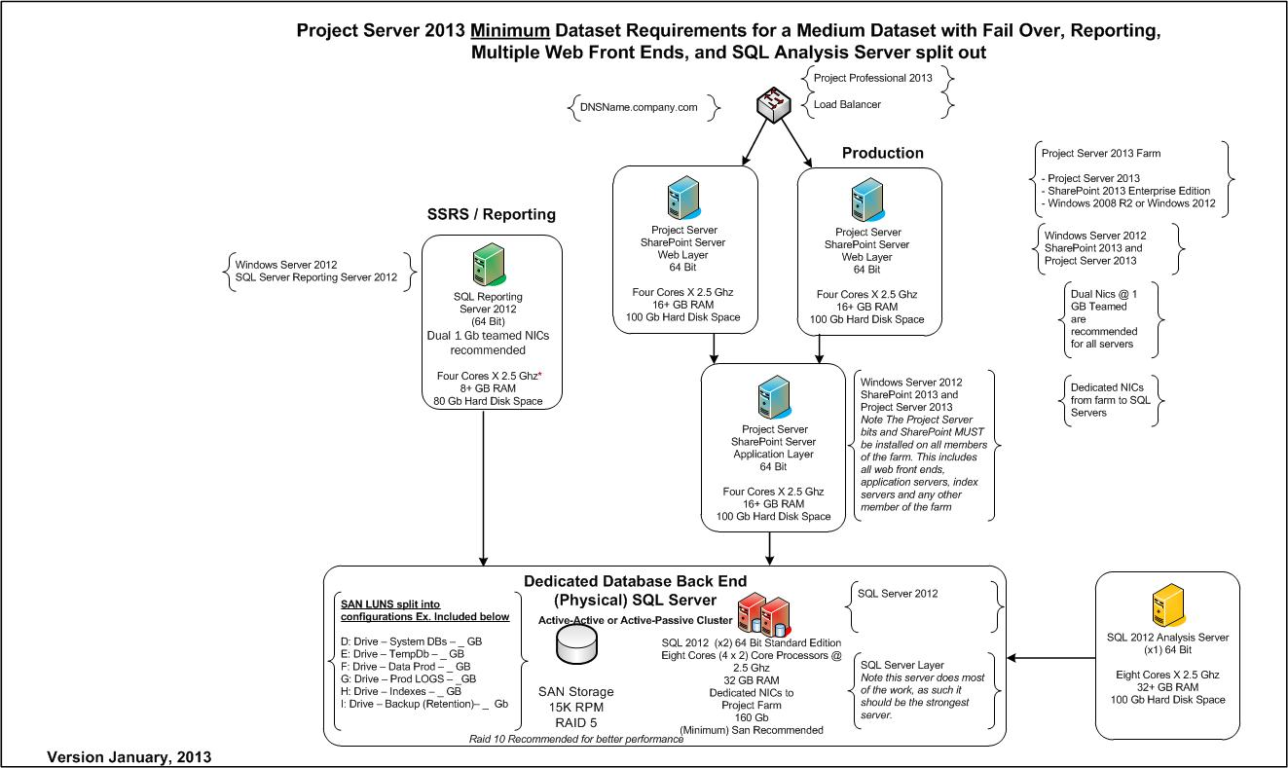
Diagram showing recommended Minimum requirements for a Medium Dataset consisting of two front end web servers, an application server, a dedicated server running Reporting Services, a dedicated SQL Server fail-over environment, and a dedicated computer for SQL Server Analysis Services
Note how the System Databases, Logs, Indexes, etc. have been placed onto separate physical hard disks

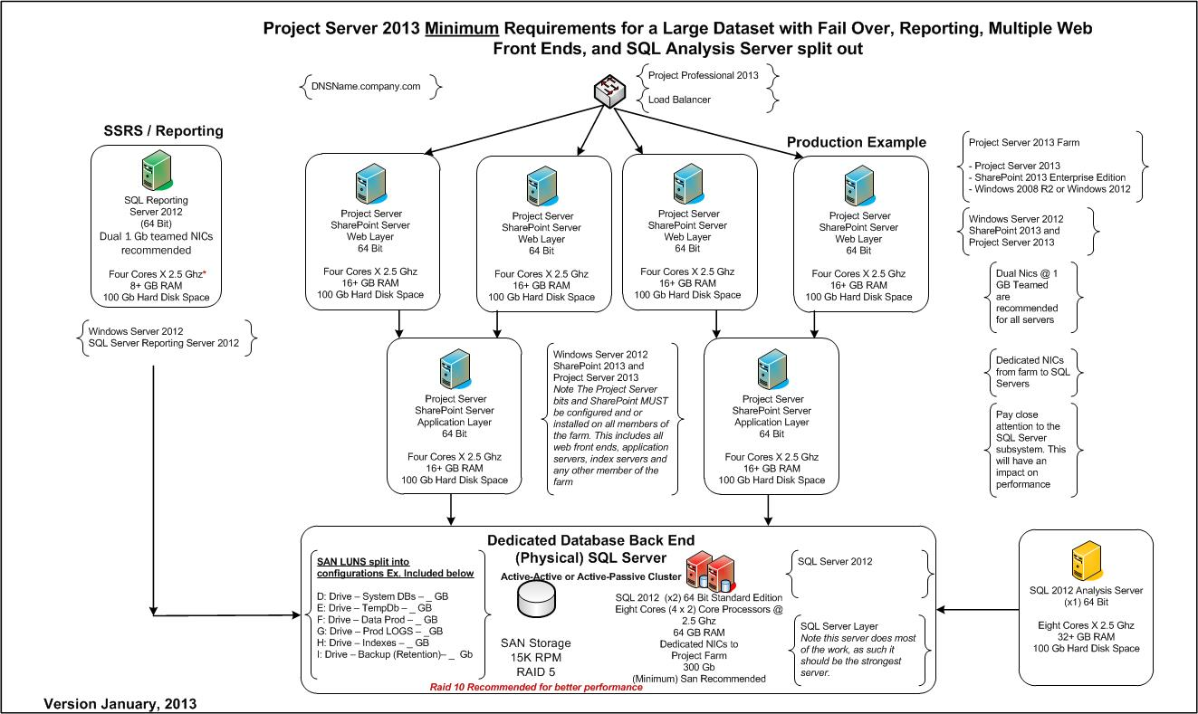
Diagram showing recommended Minimum requirements for a Large Dataset consisting of four front end web servers, two application servers, a dedicated server running Reporting Services, a dedicated SQL Server fail-over environment, and SQL Server Analysis Services
Note how the System Databases, Logs, Indexes, etc. have been placed onto separate physical hard disks
Note 1: Performance can be impacted by having one set of drives on one Raid configuration and another set of drives on another configuration.
Note 2: Raid 10 is optimized for throughput and provides faster access to reads and writes. RAID 10 is preferred over Raid 5 because RAID 5 has low write performance, approximately the same speed as for a single disk. (This is because RAID 5 has to maintain parity information, there is a write penalty due to the need to keep parity in check)
Using RAID 10 for a backup device tends to provide faster backups, the reason being RAID 10 uses all of the drives in the array to gain higher I/O rates. The downside is, RAID 10 is more expensive to implement since it requires double the space that is required. See Note 3.
Note 3: When ordering space for Raid 10 be sure to order double the amount of space. If 500 Gb is what is needed space wise, order 1024 Gb (1 Terabyte) (Double what is required) Raid 10 will require this.

Frequently asked questions for Capacity Management
Question: Should I implement a single dedicated Project Server farm? Or should I combine my Project Server farm with an existing SharePoint Server farm and have the two together in the same environment.
Reasons to keep the environments separate:
- Performance & Load. When either the SharePoint Server or the Project Server environments or both environments gets to be too large, performance takes a hit. When this occurs, it’s time to break up the load. Over the years, I have actually seen a number of customers separate their Project Server environments from their corporate SharePoint environments. The primary reason being the need to enhance performance and separate out functionality. One or both of the applications had outpaced expected growth.
- Ability to integrate and or pull data from 3rd solutions which may be required. Sometimes data feeds from third party applications can have an impact on one or both of the solutions. When data is being pulled or pushed into a solution on a regular basis, it’s always a good idea to look at having a separate dedicated system.
- Archiving. Ideally Archival environments should be a separate dedicated environments that can be used to pull data for reference purposes (as needed by other projects), legal reasons, HR (Human Resources) and more.

Reasons to have both a combined environment:
- Ability to take advantage of the Corporate Portals capabilities such as search and the ability present data in SharePoint Server via lists, web parts, and user portals.
- Licensing. Having both environments combined will save on licensing. Instead of two separate licensed environments, there is only one.
- Small Corporate Environments and light load.
- Patching. Currently both SharePoint Server 2013 and Project Server 2013 have the same service packs. The same service pack works on both. Cumulative updates however, are separate.
Question: Single I use a single instance or multiple instances? Should the instances be separated or kept together on the same server? Should I separate by Department or group?
Creating additional instances is pretty straight forward. Assuming that you have Administrative permissions, it is possible to create an additional instance within 5-10 minutes, or less. As a general rule of thumb it is a good idea to keep instances (and groups/departments) together on the same infrastructure, preferably the same instance. Keeping departments and groups together in the same instance helps to be able to track and manage resources across an organization. Security can be created, in such a way, that resources in groups or departments cannot see or have access to another group or departments projects or information. This while providing the ability for management to have clear insight into what is happening across the organization. If groups or departments are separated out, it then that task becomes much more difficult.
What about task level security? Is this possible?
Task level security is not offered at the application level.
Some organizations have implemented this by creating a master project and then promoting first level tasks as a new project plan. The master project would have its own security, and the single levels tasks (now projects) would have their own security. The tasks in effect become sub projects each with their own levels of security.
Note: Before implementing such a procedure in production, it is strongly recommended that this be tested in a separate instance (test/dev) to make sure you can obtain the results you are looking for and to make sure it meets your test requirements. As always, before testing, back everything up.
There are several clear cut exceptions for why instances should be placed onto their own dedicated hardware

Ideal times to have separate instances:
- Development environment. When testing code. Ideally, this should be placed on a separate dedicated server that contains a copy of the production data or a subset of the production data. Having separate hardware will help avoid conflicts with code causing problems (or crashes) in a production environment.

- Archival Environments: Occasionally customers have a legal requirement to keep project data, financial data, resource data, legal, and other information for many years after a project has been closed. In such situations a separate dedicated Archival Environment is warranted. When projects are closed the Project and corresponding SharePoint data can be moved into an archival environment.

- Business Requirements: Occasionally within companies, various organizations will have different standards regarding their business requirements. If these standards and methodologies cannot be agreed upon, separate instances may become necessary.
Ideal times to have multiple instance on the same server.
- Training. Training environments can typically be used by a handful of resources at a given time (20-50) A subset of production data or other training data can easily be placed into this environment and used. Once completed the instance can be deleted if needed or the data refreshed and updated accordingly
- Test (Sandbox). Need to do some testing (not code) See how a report looks, verify data, test some links. This is a great environment to do that in. Typically test environments contain either a copy of production data or a subset of data.

Question: Are there any added restrictions on the number of users you can add or that can log on at a given time?
Answer: This is one of the advantages to using either a Project 2013 On Premises or a Project 2013 On-Line solution. The solution can be scaled to handle your load.

Question: Are there size restrictions on documents?
Answer: Documents are handled by quota size for the site collection.

Question: How many PWA instances can I have with Project On-Premises?
Answer: This will depend on the load placed on to your existing environment. It is not uncommon to see 2-3 environments on a single instance.
Question: In Project Server / SharePoint Server 2013 Can a SharePoint site become a PWA site or vice versa? Can a PWA site become a SharePoint site?
Answer: In 2013 A site collection is created that contains the Project Server bits. Once this site collection is created and provisioned you will be able to create sites and subsites that will know how to be PWA like, however the site collection will first need to be provisioned this way. If the site is not provisioned with the PWA bits it will not know how to behave. With an On-Premises Solution this is a manual process and the collection must be provisioned accordingly.

Backup Restore and Disaster Recovery for Project On-Premises

Options | PROS | CONS
SQL Server Full and Differential and or Incremental Backups  Full Backups create a new (full) backup of the databases.  Note: Full backups do not include farm settings.  Differential backups create a backup of all changes that are stored in databases since the last full backup was taken.  Note:  Differential (Cumulative) Backups Require the full backup to be restored followed by the differential and then the transaction logs. | Full nightly backup  Differential or Incremental backups throughout the day in conjunction with Transaction Log backups between each incremental allows for complete data recovery.  Can be scheduled using Out of Box SQL Scheduler or by 3rd party tools.  Full backups include the database and transaction logs.  Much more robust for backing up the data and ensuring the validity of the data.  Can be combined with SQL Clustering to maintain high availability. If one SQL server goes down the databases would automatically failover. | Much more difficult to restore farm back to original state.  Must be closely monitored and data backups validated.  Differential database backups on disk or tape are not encrypted with native tools.  .
T SQL Log Backups every four hours. | Note as load intensive as farm backups.  Goto Disk or a Vendor Solution backup  Transaction Logs can be marked creating a consistent point in all databases from which one can recover | In the event of a disaster the sites would need to be relinked.  Transaction Log Marking would need to be built in.  Full crawl for SharePoint Search would be necessary after recovery
Log Shipping  Log shipping automates the process of backing up the database and transaction log files on a SQL Server –and then restores the files onto a “standby” server.  One of the key features of log shipping is that transaction logs are automatically backed up throughout the day at specified intervals. Then the transaction logs are automatically restored onto a standby SQL Server.  Depending on the backup interval the two servers are close to being in Synch. | Can be done to a remote site  Can be combined with Transaction Log Marking  Thereby creating a consistent point in all databases from which one can recover.  Ideal for less than four hour data loss  If one SQL Server fails, the “standby” SQL Server that is in synch could be renamed to the old SQL Server name the environment recovered fairly quickly.  Once implemented, Easy to maintain.  Manual failover process can be fairly short (15-45 minutes) | Would need to determine some sort of cut off point to keep sites synchronized.  In the event of a disaster Project Workspaces would need to be relinked.  Full crawl for SharePoint Search would be necessary after recovery  Transaction Log Marking would need to be built in.  If a restore job fails it can cause the log shipping for that db to get out of synch and fail.  Log Shipping failover is not automatic. The dba has to manually failover the server.  Data may be lost. The amount of data lost would depend on how often log shipping is scheduled and on the state of the transaction log.  Databases that are being failed over to the standby server cannot be used for anything else.  Requires the existing SQL Server to be LINKED.
Backup farms in SharePoint Server 2013  SharePoint Server 2013 farms can be backed up via one of three methods:  - SharePoint Central Administration Website  - Windows PowerShell  - SQL Server Tools  Note: Backing up the farm backs up the configuration and Central Administration content databases, but these cannot be restored using SharePoint 2013 tools. For more information about how to back up and restore all the farm databases, see Move all databases in SharePoint 2013 | If you want to back up the complete farm, you must use either Windows PowerShell or Central Administration. You cannot back up the complete farm by using the SQL Server tools because you cannot use the tools to back up the farm’s configuration | The complete SharePoint farm CANNOT be backed up by using SQL Server tools because the SQL Server tools cannot backup the farm’s configuration. The tools however can be used to backup all of the databases in the farm.  For more information on these methods see:  http://technet.microsoft.com/en-us/library/ee428316.aspx  Note 1: When restoring a farm, the SharePoint 2013 recovery process will restore all objects as a new instance of the object. It will not overwrite an existing instance with the same name.  What does this mean?  It means all GUIDS for objects are assigned new values. Because of this it will be necessary to recreate Alternate Access Mapping Settings. The recovery process will only restore the default zone, nothing else.  As part of this, it would be a good idea to check (verify) any references to external data sources.  Note 2: Farm backups will not backup (or be able to restore) any of the following items:  - SSL Certificates  - Network Load Balancing Settings  - Dedicated IP Address Settings  - Server domain membership  - Http compression settings  - IPsec (Internet Protocol Security) settings  - Application pool account passwords (These are located (stored) on the web server and as such are not backed up with the farm  - Custom ISAPI Filter (Usually stored on web servers)  - Time out settings

So what happens in a farm backup?
A SQL Server backup is taken of all of the databases in the farm. This includes the 2013 Project Server database, SharePoint Content Databases, Service application databases, index databases, and Search databases.
After all of the databases, in the farm, have been backed up farm configuration content is written to files. During this process the Search index files are also backed up and then synchronized with the backups of the Search database.
The diagram below illustrates how a farm backup works.

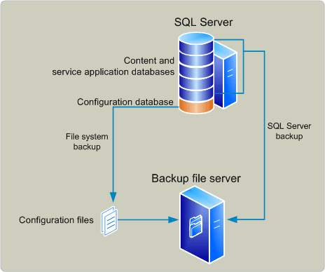
Diagram depicting how a farm backup works

Recovery Methods
SharePoint Server 2013 supports the following built in recovery methods:
- Restore from a farm backup that was created by using built-in tools.
- Restore from the backup of a component taken by using the farm backup system.
- Restore from a site collection backup.
  - Only Site Collection can be recovered from a Site Collection backup.
- Connect to a content database by using the unattached content database feature, back up or export data from it, and then restore or import the data.
See http://technet.microsoft.com/en-us/library/ee663490.aspx for more information
For more information please review the link for Overview of backup and recovery methods in SharePoint 2013 located at http://technet.microsoft.com/en-us/library/cc261687.aspx

Notes for Backup Restore and Disaster Recovery
Note 1: SQL Clustering is recommended for high availability. Best if used in an Active/Passive Mode.
Pros: If one server went down the other server would fail over, user downtime would be negligible –productivity would continue.
Cons: Additional hardware and licenses would be required.
Will need
Note 2: Any and all backups, regardless of SharePoint Farm backups and/or SQL Server backups, the drive that the data is being backed up to should be located on SAN storage, separate LUNS, separate physical disks, RAID 10 for optimum performance.
Note: If the data is more important than restoring the farm quickly, then there is ONLY one real choice…SQL Server backups. SharePoint Farm backups are not reliable enough.
Note 3: Project Server 2013 does not support scaling out the Database component through SQL replication. While it is possible to perform SQL mirroring on a Project SQL Server for the purposes of backing up data, Project Server 2013 is unable to take advantage of SQL replication to reduce read loads on the SQL Server.
SQL Server Mirroring will require the use of the Full Recovery Model. Simple will not work.
The SharePoint Content database can be mirrored to a different database server than the Project Server database. The Project Service database and SharePoint content databases do not have to be mirrored to the same server.
For a backup solution to work, you would have to mirror all of the databases making up the environment. Unless you are using SQL Server 2012, the mirrored databases will not be readable until they are taken out of the mirroring scheme. In order to use a mirrored database for reporting purposes you will need to take a snapshot of the mirror and read from the snapshot.
One of the features of SQL 2012 is that it now permits the mirror to be used in read mode. This was not the case in SQL Server 2008 R2. (although you could take a snapshot of the mirror and then use the snapshot to read the data) If using SQL Server 2008 R2 the mirror will need to be detached or reversed before being used.
Note 4: Replication of data over a Wide Area Network is not adviseable. Why? There is a lot of data mismatch due to the number of databases. In 2013, while it is expected to perform better, there is a still a risk of data mismatch.
Note 5: Please reference the following links for more information:
Backup farms in SharePoint 2013 http://technet.microsoft.com/en-us/library/ee428316.aspx
Move all databases in SharePoint 2013 http://technet.microsoft.com/en-us/library/cc512725.aspx
Plan for user authentication in SharePoint 2013 http://technet.microsoft.com/en-us/library/cc262350.aspx
Overview of backup and recovery in SharePoint 2013 http://technet.microsoft.com/en-us/library/cc261687.aspx

Operational Best Practices for Project Server 2013 On-Premises
- SQL Maintenance Plans
  - Full backups should occur on a nightly basis. Ideally SQL Maintenance plans should be setup to do nightly backups.
  - Log files should be truncated on a regular basis
  - SharePoint Content Databases. Add more content databases as needed. A good idea for when to add additional SharePoint content databases is when the databases get to be around 150 GB to 200 GB.
  - SharePoint Central Administration has a Help Job that can be created as a scheduled job in SharePoint Central Administration. This job can be used to run daily maintenance jobs such as defragmentation.

- Best Practices around Applying Service Packs and Cumulative Update
  - Before applying any service packs or cumulative updates, it is always a good idea to first take a backup of the databases, and of any servers which have had customizations applied to them.
  - Ideally Service Pack and Cumulative Updates should be planned for weekends or at nights when people are not on the servers. The amount of time required to implement the updates will depend on the amount of data.
  - Project Server 2013 now has a Read only mode. By running a Windows PowerShell command it will put the PWA site into a Read-Only Mode. The benefit this has, is that users can still look at the data while a service pack or a cumulative update is being applied, however they will not be able to update any information until the site has been returned to it’s active (read/write) mode. This command facilitates maintenance and software updates.
  - A List of the 53 Project Server Windows PowerShell commands has been provided in the appendix. These commands can be used for operational maintenance and can be your best friend. Get to know them.

- Monitoring
Monitoring has been enhanced for both Project Server On-Premises and On-Line. Enhancements include:
  - Comprehensive ULS Logs
  - Fully integrated monitoring with diagnostic service
  - Complete developer dashboard
  - Log Level Manager
  - Queue Stat Manager
  - 53 Project Server Windows PowerShell cmdlets

Planning the implementation (Checklist)

Review the Prerequisites: What do I need to deploy Project Server 2013 On-Premises.
- SharePoint Server 2013 Enterprise Edition
- Project Professional 2013
- Workflow: For workflow, the workflow infrastructure (Workflow Manager 1.0) for on-premises solutions will need to be installed with SharePoint Server 2013.

Server Requirements
- Supported Windows Server Operating Systems
The following Windows Server Operating Systems are supported for use with Project Server 2013
Windows Server 2012 Operating System | Version
Windows Server 2012 (64 Bit) | Standard Edition
Windows Server 2012 (64 Bit) | Database Edition

Windows Server 2008 R2 | Version
Windows Server 2008 R2 SP1 (64 Bit) | Standard Edition
Windows Server 2008 R2 SP1 (64 Bit) | Enterprise Edition
Windows Server 2008 R2 SP1 (64 Bit) | Datacenter Edition
Note 1: All versions of Windows Server 2008 R2 must be running Sp1
Note 2: Ideally, all 64 Bit servers should have a minimum of 8 Gb of Ram in order to take be able to take advantage of the 64 bit chip set.
8 Gb of ram is recommended for developer and or evaluation use.
16+ Gb of ram is recommended for production use in single server, and multiple server farms. 64 bit servers with 2-3 Gb of ram will not be able to take complete advantage of the 64 bit chip set.

Note 3: Server Core Installations of Windows Server 2008 R2 are not supported

Note 4: 64 Bit 2.5 Ghz 4 Core minimum, with 80 Gb of hard disk space for all front end (web layer) and application layer servers.
Why would I want to choose one version of Windows over another?
Windows 2012 brings some nice storage options to the table.
For more information see:
http://www.microsoft.com/en-us/server-cloud/windows-server/storage.aspx

- SQL Server Requirements
The following SQL Server Editions are supported for use with Project Server 2013
SQL Server 2012 | Version
SQL Server 2008 R2 SP1 | 64 Bit
SQL Server 2012 Standard Edition | 64 Bit
SQL Server 2012 BI Edition | 64 Bit * Allows PowerPivot, SSRS, and BI optomizations
SQL Server 2012 Enterprise Edition | 64 Bit * Allows all of the above (BI Edition) + permits highly scalable deployments
Ensure that the following SQL Server Components are installed:
Database Engine
Analysis Services
Management Tools
Connectivity Components
*Note: The SQL Server Service Agent Service must be running.
*SQL Server Reporting Services is optional
*PowerPivot is optional
Why would I want to choose one version of SQL Server over another?
SQL Server 2012 brings Always On (for Disaster Recovery and High Availability). It also brings Powerview for Reporting.
For more information see
http://www.microsoft.com/en-us/sqlserver/solutions-technologies/mission-critical-operations/high-availability.aspx
http://msdn.microsoft.com/en-us/library/bb510411(v=SQL.110).aspx
- SharePoint Requirements
SharePoint 2013 Enterprise Edition is required to run Project Server 2013

Client Requirements

- Desktop
  - Windows 7 & Windows 8 - 32 bit or 64 bit
- Project Professional
Note 1: Project Server 2013 will only accept connections from Project Professional 2013. There is no backward compatibility mode that will permit Project Server 2013 or Project Professional 2013 to connect to Project Server 2010 or Project Professional 2010.
Note 2: Project Professional 2013 and Project Standard 2013 cannot and should not be installed side by side. Why? They contain essentially the same set of bits, albeit with different features.

Note 3: Project Professional 2013 (MSI) and Office 365 Professional can be installed on the same workstation, and both can be operated at the same time.

Requirements for Project Professional 2013
Component | Minimum Requirement
Workstation and Processor | 1.0 Ghz or higher x86/x64 with SSE2 instruction set
Memory | 1 Gb of Ram for (32 Bit) / 2 Gb of Ram (64 Bit)
Hard Disk Space | 2.0 Gb Available
Operating System | Windows 7 or Windows 8  Windows Server 2008 R2 or  Windows Server 2012 with .Net 3.5 or greater  *Note for Project Online, the Server(s) and .Net infrastructure components are provided for you.
Graphics | Direct X Graphics Card (for Graphics Hardware Acceleration)  1024 x 576 minimum resolution
Browser | Internet Explorer 10.0, 9.9, 8.0, Safari 5 (Mac), Firefox 10.0+, Chrome 17.x
.Net Framework | 3.5 or 4.0
Other | Touch Feature require a touch enabled Windows 7 or Windows 8 PC. Some functionality will require internet connectivity.  *Note 1: Lync is required for presence notification  *Note 2: Microsoft SharePoint Online is required for task synchronization  *Note 3: Some visual reports may be built with Excel 2007, 2010, 2013, and Visio 2007, Visio 2010, Visio 2013.  Any connections to the Reporting Table in the Project Service Database using OData will require the use of Excel 2013

- Internet Explorer
Project Web Access (PWA) 2013 is compatible with all browsers used by SharePoint Server 2013. For Internet Explorer this means:
Internet Explorer 10
Internet Explorer 9 &
Internet Explorer 8

Internet Explorer 7 or lower is not supported.

- Other Browsers and Applications (IPAD)
MAC Safari 5.0 or higher

To verify compatibility with an IPAD, the version of Safari on the IPAD should be the same as the version of the I OS (Operating System) Check the version of I OS. Safari on the IPAD does not have its own version number as it would on a PC or a MAC.
Firefox 10
Google Chrome 17
Note 1: All PWA roles are supported. This includes timesheets, portfolio analysis, and project center. It is possible for example to do portfolio analysis in Firefox, and access project center views in Safari. It is also possible to update on an IPAD and then see the changes on an iPhone. A significant improvement from the past.
Note 2: After you install Project Server 2013, it cannot be uninstalled from the farm. If you want to remove Project Server 2013 functionality, you can turn off the Project Application Service and delete the Project Server 2013 Service Application.

Mobile Browsers
Yes, that is correct. New to Project Server 2013 is the introduction of mobile sites. This new addition permits team members and project managers to view and in some cases even update their projects. If you have a touch-enabled mobile site, you will also be able to access and edit project documents and perform basic editing of your project plans.

Team members can now view task assignments, documents, and the project status roll up for their Project Server projects. If team members have a Microsoft Exchange client on their phone they will also be able to edit and submit task status.

Projects Managers can now view up to date status information from resource, regardless of where they are, make minor updates to project plans, and check on the overall status of their projects all on the fly, and all while using a mobile device.
Requirements:
Windows Phone 7.5 or greater (using the Internet Explorer 9 browser)
Apple iPhone
Android
*Microsoft Exchange Client on a Windows phone is required to be able to submit and edit task status on a Windows phone

Additional requirements

The table below shows the requirements for some of Project Server 2013’s features. The table provides the requirements for each of the components
Component | Requirements | Notes
Workflow Editing | SharePoint Designer 2013 & Microsoft Visio 2013 | Both are required
Workflow
Active Directory Synchronization | The Domain Controller(s) must have one of the following Operating Systems:  Windows Server 2003  Windows Server 2008  Windows Server 2008 R2 | For Synchronizing Resources and Security Groups in Project Server
My Tasks feature | Server: Exchange Server 2013  Supported Outlook Versions:  Outlook 2013  Outlook 2010  Microsoft Office Outlook 2007  Microsoft Office Outlook 2003  Supported Mobile Versions  Windows Phone 7..5 or newer  iApple: OS 5 or newer  Android 2.3 or newer | Permits task synchronization between Exchange Server 2013, Project Server 2013, and SharePoint Server 2013  Note 1: The Work Management Application Service must be enabled.  Note 2: Exchange Server 2013 and SharePoint Server 2013 MUST be on the same domain.  Note 3: The Auto Discover Service must be configured and functional.  Note 4: Hybrid Solutions (Meaning On Premises with On Line) are not supported. You cannot integrate an On-Premises Solution with a solution provided by a secure data center.
Lync | The following versions and conditions are supported:  Lynch 2013 with Internet Explorer 9, 8, Firefox 10, or Google Chrome 17  Lynch 2010 with Internet Explorer 9 or 8  Note: Internet Explorer 9, 8, Firefox 10, and Google Chrome 17 with any Office 2013 application will provide the user with a contact card, but not a Lync presence. | Can be used in either Project Web App (PWA) or Project Professional  Note: Lync presence and contact card on the desktop version of Internet Explorer 10. It will not work in the ‘Tile’ Version of IE 10.
Reporting | On Line:  Excel 2013  On Premises:  Excel 2013  Excel 2010 | Reporting through OData (for both On Line and On Premises Solutions) will require Excel 2013

Virtualization
As with the physical environments, many of the same questions come into play for the VM guests, including the size of databases, the size of file systems and the number of (virtual) CPUs, memory, etc. Other considerations include:
A key note to the virtualized environments is to understand where system contention may affect response times comparable to the physical servers. Typical areas to watch for are:
- Physical container characteristics
- Disk IO on the virtualized file
- Number of logical CPUs
- Logical memory allocation
- Virtual memory address space
- System resource contention across shared applications.

If you are considering virtualizing servers, consider virtualizing the front end (web) servers, the application layers and leaving the SQL Servers as physical.
Keep in mind virtualized servers are really slices from a parent server. They utilize resources provided by the parent server, which in turn shares it resources across multiple applications. As a result, virtualized servers sometimes compete for resources, resulting in a “traffic jam”, and slow performance. (Think Washington D.C., Los Angeles, Chicago, or Boston traffic, (all of which the author has experienced firsthand during rush hour) Not a pleasant experience for the end user. To avoid this, it is imperative that system resource contention be monitored during normal business hours and adjustments be made as needed to avoid any system or resource contention.

Hybrid Solutions
What Hybrid Solutions are supported?
For Project Server, with the exception noted below, no hybrid solutions are supported. Either the environment is completely On-Line or it is completely On-Premises.
What is the exception? Project Pro for Office 365 can be used to connect to an on-premises instance of Project Server 2013.

For SharePoint Hybrid Solutions
For supported SharePoint hybrid solutions see http://technet.microsoft.com/en-us/library/jj838715.aspx
Note: While SharePoint 2013 supports Directory Synchronization, meaning user accounts in an On-Premises Active Directory Domain Services domain automatically synchronize to Office 365 this does NOT hold true for Project Server.
What Hybrid Solutions are not supported?
Currently, with the single exception noted above, no hybrid solutions are supported for Project Server. It is especially important to note that Project Server does not a hybrid solution where Project Online is integrated with an On-Premises Exchange Solution.
The reverse is also not supported.
A hybrid solution where Project On-Premises is integrated with Exchange Online. Project Online is an Office 365 Solution that will be integrated with Exchange Online.
That said it is possible to have a solution where an On-Line Solution can connect to a third party solution and have data pushed and pulled. For more information and for a good example see the Microsoft white paper. Microsoft however is not responsible, nor does it support any content being pushed and pulled into the system.

Upgrade Overview

Upgrading to Project Server 2013, from previous versions, to an On-Premises Solution is a process that will require a dedicated Project Server 2013 environment. It will also require time since all of the Project Server databases will need to be upgraded from previous versions until they have been successfully upgraded to Project Server 2013. There is no direct upgrade path from 2003 or 2007 to 2013. For example, an upgrade from 2003 to 2013 would first require upgrading to 2007, and then to 2010, and finally to 2013. The upgrade must follow an established migration path for it to be successful.
Note: if upgrading from Project Server 2007 your 2007 environment MUST be running Sp2 or higher
What this means is that Project Server 2013 will need to be installed into its own dedicated environment. It is this ‘destination’ environment that will be used to upgrade your existing 2010 Project Server databases and your SharePoint Content database.
Note: An in place 2010 upgrade option (where Project Server files are upgraded on the same 2010 hardware) is not supported. What is supported, is a database attach method into a dedicated Project Server 2013 environment.
Overview of the migration process:
When you migrate the four Project Server 2010 databases to Project Server 2013, a database consolidation occurs. During this process the four project server databases are consolidated into a single Project Service database. As a part of this the PWA configuration is migrated to 2013.
Note: Customizations such as web parts and customer solutions will need to be redeployed manually to the 2013 environment.
In order to migrate to Project Server 2013 the following steps will need to followed:
- Create a new Project Server 2013 farm.
- Set the 2010 farm to read only (this permits users to access the 2010 farm in a read only format)
- Create backups of the four project server databases and the Sharepoint content databases
- Restore the databases to the server that is running SQL Server that is hosting your Project Server 2013 farm databases.
- Upgrade the databases.
- Upgrade the PWA Site collection and then enable PWA features for the site.
- Create an Olap Cube
- Test Test Test
Post Upgrade tasks:
- Enable Issues and Risks links
- Add the Project Server 2013 Enterprise Project Types
- Determine which form of authentication you want to use. If you wish to continue to use Windows Authentication, keep in mind the upgrade process is now using Claims authentication. You will need to use a Windows PowerShell command to switch back to Windows authentication.
- Verify custom code
- Verify workflows
- Verify Reports
- Verify your upgraded databases are running the most up to date service packs and project server cumulative updates. Typically new cumulative updates are released every two months.
- Test Test Test
- After everything is successful, backup the databases and the farm.

For more information on the upgrade process please see http://technet.microsoft.com/en-us/library/ee662496.aspx
Note 1 : Backward Compatibility mode is no longer supported.
Note 2 : When migrating from Project Server 2010 to Project Server 2013 there is an automatic database consolidation. The four project server databases (Archive, Draft, Published, and Reporting) are consolidated into a single Project Server database called Project Service. The former databases are then referenced by their table names. Only the Reporting database tables in the Project Service database will be exposed for reporting purposes.
Note 3: The reporting data tables and views have been optimized for read-only report generation. Reporting data is comprehensive and can be updated almost in real time.
Note 4: Project Server 2013 does NOT use active-x controls.
Note 5: Microsoft is NOT responsible for any integration with third party systems.

- 2013 – Upgrading to 2013 will require new hardware. The 2010 databases will then need to be attached and upgraded.
Note: An existing 2010 server environment cannot be upgraded (eg. an upgrade an inplace) Only a db attach method to an existing 2013 environment is supported.

For more information on upgrading from Project Server 2010 to Project Server 2013 please see the following link: http://technet.microsoft.com/en-us/library/gg502590.aspx

If upgrading from Project Server 2010 to 2013 Online you have several options.
- Upgrade manually and or use some vba.
Any custom solutions such as web parts will need to be manually recreated in a 2013 Online environment.
Projects can be saved as .mpps and uploaded manually.
Custom Fields will need to be recreated manually.
Enterprise Global, you will need to recreate this manually.
Workspaces: These will need to be recreated manually.
Security:
a. You will need to determine if you want to use Claims Authentication or Classic Windows Authentication.
b. You will also need to determine if you want to use SharePoint security or the default Project Server security. Either one will need to created or recreated manually. Be extremely careful about experimenting with and or switching between Project Server security and SharePoint security.

- Use a third party tool such as Fluent Pro
  - Use of Fluent Pro will require the installation of Project Professional 2013. The fluentpro migrator is actually an add-in for Project Professional 2013. This add-in permits the migration of project schedules between Project Online 2010 and Project 2013 On-Premises Solutions. It can also be used to migrate data between 2013 instances. As of this writing it cannot be used to migrate data from a Project 2010 On-Premises Solution to a Project 2010 On-Premises Solution. It’s use is currently limited to moving data into and out of Online solutions and moving data between 2013 online instances.
    - There are two editions of fluent pro. Free and the Professional Edition.
Free: Per http://projectmigrator.com/fluentprocloudmigratorfree.html the free edition only supports a one way migration from Project Server 2010 to Project Online Preview. RTM (Release to manufacturer) migration support is NOT provided. It is also limited to use by two instances on the same server. (For example production and test)
Professional: Per http://projectmigrator.com/fluentprocloudmigrator.html the Professional Edition only supports a one way migration from Project Server 2010 to Project Online. The professional version will not work with Project Server 2013 On-Premises. Additionally it can only be used for 2 PWA instances on the same server. This version however, will work with RTM (Release to manufacturer) code.
For more information on the use of fluent pro and what can be migrated, please see the links above.
    - Note: This information is provided as a courtesy and is an example of a tool that can be used to import (migrate) into Project 2010 data into a Project 2013 Online environment. Mention of this product does not imply endorsement, by Microsoft, of the fluent pro product. Microsoft does not and cannot be responsible for any data imported, data not imported, or migrated through the use of the Fluent Pro. Tool.

Note: Regardless of whether you chose to move to Project online manually or use a third party tool. It is important to note that some components will need to be redeveloped or modified when moving to Project Online. This components include but are not necessarily limited to:
- Custom Code
- Workflows
- Reports
- Security
- Custom Fields (type these in)
- Workspaces
- Integration with third party applications

reports (which one, custom code, workflow
Known issues after upgrading from Project Server 2007 to Project Server 2010
A known issue that can occur during the upgrade process from 2007 to 2010 is a 404 error when you try to access the SharePoint Central Administration home page. This same error can also occur when patches or cumulative updates are applied. Please note, the error in this case, is related to IIS, and is a relatively straight forward fix. Should this occur open up IIS, expand Sites, Right Click on SharePoint Central Administration, select or click Manage Web Site, Advanced Settings. You should see a screen similar to the one below.
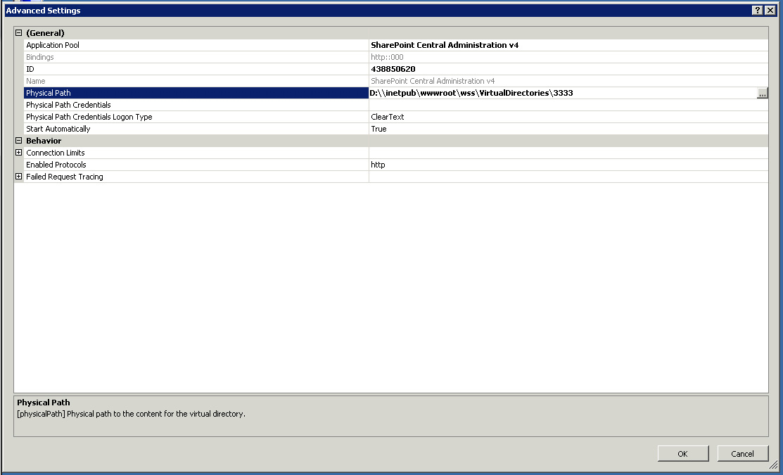
Under Physical path look at the drive letter and take note of the two \\’s. There should only be one.
Remove (delete) one of the backslashes, so that the path reads :\ In the above example the corrected path would read D:\ click OK. Open a command prompt, (Run As Administrator) and perform an iisreset
SharePoint Central Administration should now function correctly.
Another known issue, that can sometimes occur, after the upgrade process is that of duplicate web
parts. Usually duplicate web parts are the result of actions that occurred at some point in the past and only show up after the upgrade process. It is important to note that the upgrade process does not cause duplicate web parts. Should duplicate web parts be seen, they can usually be cleaned up fairly quickly.
First take a backup of the databases
Second take a backup of the servers.
Next, it is important to look at both web parts and determine which one(s) you want to keep and then close the other web part(s).
Finally Test and Verify the web parts are acting as they should.
An example of how to close a duplicate web part in a document library has been included below.

- Open the document library where you are seeing the duplicate web parts.
- Click on Site Actions ->Edit Page
- Now for the web part you want to close, on the top right corner, look for a drop down menu.
- Click on the drop down menu and select “close web part”
The web part should now be closed.

Note 1 : If upgrading from Project Server 2007 to 2010, using the db attach method, be sure to create a new Project Server instance on the destination server. Once the databases are attached, they can be upgraded.

Note 2: Contrary to popular belief a single site cannot simply be added to a 2010 environment from a 2007 environment or a 2013 environment from a 2010 environment and expect to be upgraded. Upgrading individual sites requires that the site or sites first be exported and imported into a new, preferably dedicated, SharePoint content database. This database can then be upgraded from 2007 to 2010 or from 2010 to 2013, using the db-attach method and the site can then be moved into the appropriate site collection, after the upgrade.
This is especially import if consolidating (merging) multiple environments into a single environment.
Known issues after upgrading from Project Server 2010 to Project Server 2013:
Claims Authentication. After upgrading a database from Project Server 2010 to 2013 the database will be in Claims Authentication Mode. The following command will need to be run in Windows PowerShell, to convert the users to Claims Authentication. If this is not done, users will not be able to log into PWA after the upgrade.
(Get-SPWebApplication <webappURL>).migrateUsers($true)
For example:
(Get-SPWebApplication http://contoso:80).migrateUsers($true)++++++

Another known issue after upgrading from Project Server 2010 to Project Server 2013 is that on the Project Center page, if you click New on the ribbon, you will only see the Basic Project EPT that was migrated from Project Server 2010. The two default EPT’s (Enterprise Project and SharePoint Tasks List) that come out of the box with Project Server 2013 when it is installed are missing.
To fix this problem the Basic Project EPT that was migrated from Project Server 2010 will need to be renamed to Enterprise Project and the SharePoint Tasks Lists EPT will need to be added. Once the two steps have been correctly completed the Enterprise Project Types page will display both the SharePoint Tasks List and the Enterprise Project EPT’s
To rename the migrated 2010 EPT to Enterprise Project, use the following steps:
- In PWA=>Settings=>Project Web App Settings
- Click or select Enterprise Project types (Under Workflow and Project Details)
- In the name column click basic Project
- In the name field change or update the text to state Enterprise Project
- Click Ok and save
- Verify that the Enterprise Project EPT now correctly displays on the Enterprise Project Types Page.
To add a SharePoint Tasks List as an Enterprise Project Type, use the following steps:
- In PWA=Settings=>Project Web App Settings
- Click or select Enterprise Project types (Under Workflow and Project Details) (Same as before)
- Click New Enterprise Project Type
- For the name field use SharePoint Tasks List
- Provide a description that references SharePoint Tasks List (so you or someone else will know what it is)
- Find the section entitled SharePoint Tasks List Project
  - Click Create New Projects as SharePoint Tasks List Project
  - Under New Project Page/Project Details Page =>Project Details
  - Find a list entitled Available Project Details Page and move Project details and schedule to the box on the right. Use the up and down buttons to ensure that Project Details is listed first and schedule is listed second.
  - Next find the Defaults Section and select Use this as the default Enterprise Project Type during Project Create
  - In the image section find the Type the URL field and type /_layouts/15/inc/pwa/images/CenterNormalProject.png
    - This will specify the location of the default image for the SharePoint Tasks List EPT.
  - Click on Click here to test to verify that the image is found in the default location.
  - Leave the other options with the default value and click save
Another known issue after upgrading is one that has been found in both the upgrade from Project Server 2007 to 2010 and from Project Server 2010 to 2013.
After upgrading your project plans Issues and Risks will stop working. In order for Issues and Risks to work, a bulk update of all project sites will need to be performed. The site path information will need to be upgraded. This can be accomplished via the Bulk Update Project Sites page in the Project Web App settings in SharePoint Central Administration.
*Note 1: In some situations it may be necessary to manually update a handful of sites.
For more information, see the Bulk Update Project Sites Link for 2013 http://technet.microsoft.com/en-us/library/gg982995.aspx
Once all of the sites have been updated, each project that contains a link will need to be published. The publish action is the final step required to move Issues and Risks over to Project Server 2013.
Note: If projects are not published, link items will not display.
Note 2: Document Library links to tasks are not migrated to Project Server 2010 during the upgrade process. It is important to note that the 2010 document library links will not display after they are upgraded. New document library links can however be added to Project Server 2013.

Permissions Mode (Project Server and SharePoint Modes)
A known issue after installing Project Server 2013 is the permissions mode. By default Project Server 2013 is set to use SharePoint mode. For those who are accustomed to using the standard Project Server permissions, you still can, however, after installing or after upgrading, the permission mode will need to be changed. This applies to both On-Premises and On-Line environments. For On-Premises the permission mode can be changed through the Set-SPProjectPermissionMode Windows PowerShell command.
For On-Line it can be changed through an Admin setting.
Click on the PWA Instance=>From the Site Collections Menu=>select Project Web App.
From the Project Web App drop down menu select Settings. The following screen will appear.
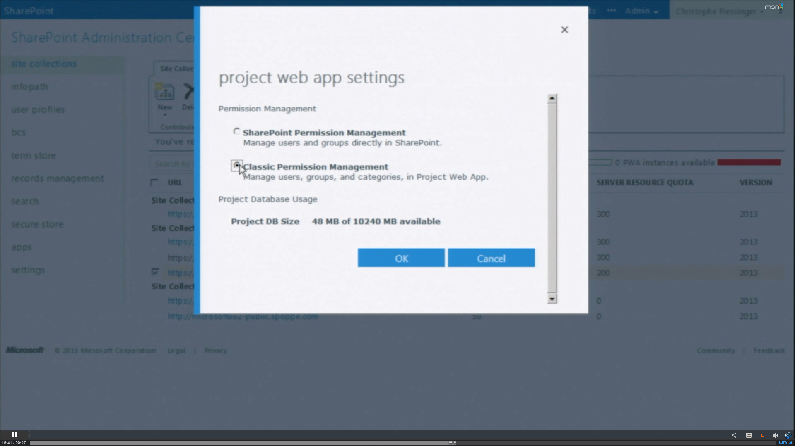
Here select the permission mode that you want to use.
A way to determine what mode you are in is to look at the pwa settings. Are the standard Project Server 2010 Users, Group, and Categories present? If not, chances are you are SharePoint permission mode, and will need to change or update to Classic Permissions Management as shown in the screenshot above, should you desire to use them. Or vice versa.
The screenshot below shows the On-Line version security settings with Manage Users, Manage Groups,
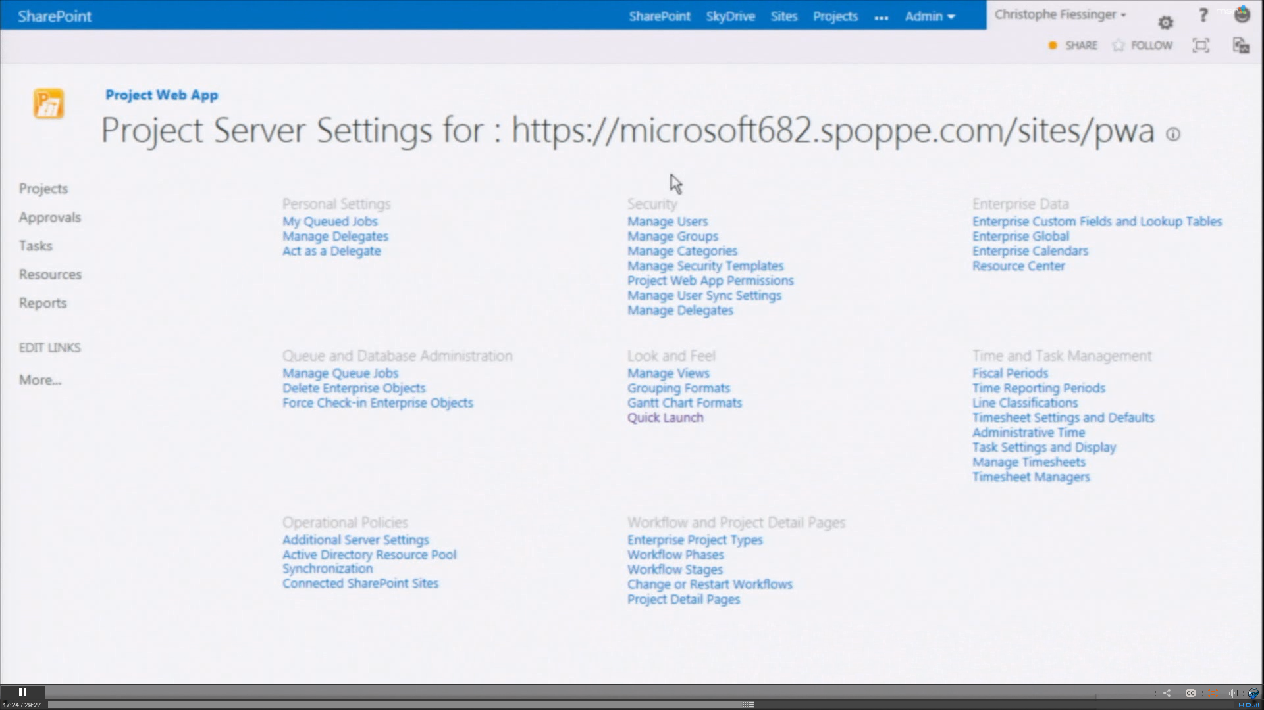
It is important to note that while you can easily switch between the two permission modes, if in Project Server you have created or you end up creating a set of custom security settings and then change or revert to SharePoint permission mode, all of these settings will be lost.
The same applies when switching between SharePoint Permission Mode and Project Permission Mode or vice versa. Making the switch deletes all security related settings, and you will have to manually reconfigure your security permissions and their structures.
So, think twice before you change permission modes! If you are unsure, or want to experiment, take a subset of production data and test in a separate instance.
For more information on SharePoint Permissions Mode, please see the SharePoint Permission mode section of http://technet.microsoft.com/en-us/library/ff631142.aspx#section17
Note: With Project Server Permission mode, you can synchronize Enterprise Resource Pools, Security Groups, etc.
SharePoint Permission Mode is simpler and as such does not require synchronization between Project Server and SharePoint Sites.

Claims Authentication
When you first look at Project On-Premises or Project Online or you will notice that some of the security settings menus are missing. Why? This is because Project by default is using Claims Authentication. The missing settings can easily be restored.
Windows Classic Mode will go away in a future release of SharePoint Server. Because of this it has been removed as the default form of authentication. Windows Classic mode can, however, still be used.
Claims Authentication is the default form of authentication in Project Server 2013 and SharePoint Server 2013.
After upgrading a database from Project Server 2010 to 2013 the database will be in Claims Authentication Mode. The following command will need to be run in Windows PowerShell, to convert the users to Claims Authentication. If this is not done, users will not be able to log into PWA after the upgrade.
(Get-SPWebApplication <webappURL>).migrateUsers($true)
For example:
(Get-SPWebApplication http://contoso:80).migrateUsers($true)
Note: The migrate users method in SharePoint Server 2010 is no longer the correct way to migrate accounts. That feature has been deprecated. Use the Get-SPWebApplication Windows PowerShell command to migrate users.
Note 1: One of the big improvements is that SharePoint Server tracks FedAuth Cookies in the new Distributed Cache Service. In 2010 if more than a single web front end was present, each had its own copy, which meant that if you were to be redirected to a different web front end, you would need to reauthenticate. In 2013 by moving the cache of FedAuth cookies to the Distributed Cache Service this problem was eliminated. It also means that sticky sessions are no longer required when using SAML claims in Project Server 2013.
Note 2: One of new claims features for SharePoint Server 2013 and therefore Project Server 2013 is that in SharePoint Server 2013 you can now add multiple token signing certificates to SharePoint Server. In the past when a token signing certificate expired, this resulted in downtime, if only a single certificate was present. This was due to the need to update the Trusted Identity token issuer with a new token signing certificate. While that is occurring, this prevented users from signing in because the new token signing certificate was not yet be trusted by SharePoint Server, and so it will view it as an invalid token. In version 2013 this has been addressed by adding support for multiple token signing certificates. As a result that downtime can now be avoided.

Appendix

What does the CSOM do and not do? See http://msdn.microsoft.com/en-us/library/jj163082.aspx
What does the PSI do and not do? See http://msdn.microsoft.com/en-us/library/ee767706.aspx

Project Server 2013 Windows PowerShell Commands
A list of Project Servers 53 Windows PowerShell Commands New for Project Server 2013 in alphabetical order
Note: These can also be accessed by typing get-command *spproject* at a SharePoint Windows PowerShell console as an Administrator
Command Type Name Module Name
Cmdlet | Add-SPProjectLogLevelManager | Adds an entity (project, resource, task, timesheet, and so on) to the Project Server 2013 internal watch list for the specified instance of Project Web App
Cmdlet | Clear-SPProjectLogLevelManager | Removes all entities on the watch list for the specified instance of Project Web App.
Cmdlet | ConvertTo-SPProjectDatabase | Combines the Project Server 2010 Draft, Publish, Reporting, and Archive databases into a single Project Web App database.
Cmdlet | Disable-SPProjectActiveDirectoryEnterpriseResourcePoolSynch | Disables Timer Job execution of the Active Directory Enterprise Resource Pool synchronization
Cmdlet | Disable-SPProjectQueueStatsMonitoring
Cmdlet | Dismount-SPProjectDatabase | Detaches the given Project Web App database from its currently associated Web application
Cmdlet | Dismount-SPProjectWebInstance | Removes an existing instance of a Project Web Instance
Cmdlet | Enable-SPProjectActiveDirectoryEnterpriseResourcePoolSynch | Enables Timer Job execution of the Active Directory Enterprise Resource Pool synchronization
Cmdlet | Enable-SPProjectQueueStatsMonitoring
Cmdlet | Get-SPProjectDatabaseQuota | This cmdlet is for Microsoft internal use only.
Cmdlet | Get-SPProjectDatabaseState | Returns the current state of a Project Web App database
Cmdlet | Get-SPProjectLogLevelManager | Retrieves the values of an existing record in the Project Server internal watch list for the specified instance of Project Web App
Cmdlet | Get-SPProjectOdataConfiguration | Returns the settings for how the OData service is configured for an instance of Project Web App
Cmdlet | Get-SPProjectPCSSettings | Gets the settings for the Project Calculation Engine on the Project Server 2013
Cmdlet | Get-SPProjectPermissionMode | Returns the permission mode for a Project Web App instance
Cmdlet | Get-SPProjectQueueSettings | Returns a list of all Project Server 2013 Queue settings and their current values for the specified Project Server service application
Cmdlet | Get-SPProjectWebInstance | Returns an instance of a Project Web App site.
Cmdlet | Grant-SPProjectAdministratorAccess | Grants administrator permissions for the specified instance of Project Web App to the specified user or group.
Cmdlet | Invoke-SPProjectActiveDirectoryEnterpriseResourcePoolSync | Triggers Active Directory Enterprise Resource Pool synchronization on the specified instance of Project Web App
Cmdlet | Invoke-SPProjectActiveDirectoryGroupSync | Manually starts the synchronization job to synchronize Project Server 2013 group membership with the specified Active Directory groups
Cmdlet | Mount-SPProjectDatabase | Creates a Project Web App database and attaches it to a web application or Project Server service application, or attaches an existing database to a web application or Project Server service application
Cmdlet | Mount-SPProjectWebInstance | Creates a new instance of a Project Web Instance
Cmdlet | New-SPProjectDatabase | Creates a new Project Web App database and attaches it to the specified web application or Project Server service application
Cmdlet | New-SPProjectServiceApplication | Creates a new Project Server service application
Cmdlet | New-SPProjectServiceApplicationProxy | Creates a proxy for a Project Server service application.
Cmdlet | Pause-SPProjectWebInstance | Switches the specified instance of Project Web App to read-only, preventing any changes from being made through the Project Server 2013 PSI or CSOM.
Cmdlet | Remove-SPProjectDatabase | Dismounts the Project Web App database from the site collection and drops it from SQL Server
Cmdlet | Remove-SPProjectLogLevelManager | Removes an entity (project, resource, task, timesheet, and so on) from the Project Server 2013 internal watch list for the specified instance of Project Web App
Cmdlet | Repair-SPProjectWebInstance | Re-queues specific Project Server 2013 queue items that may have fallen out of the queue.
Cmdlet | Reset-SPProjectPCSSettings | Resets the settings for the Project Calculation Engine on Project Server 2013.
Cmdlet | Reset-SPProjectQueueSettings | Resets all Project Server Queue settings to their default values for a specific Project Server service application.
Cmdlet | Resume-SPProjectWebInstance | Switches the specified instance of Project Web App to read-write mode, allowing users to change data again
Cmdlet | Set-SPProjectDatabase | Sets the properties of a Project Web App database
Cmdlet | Set-SPProjectDatabaseQuota | This cmdlet is for Microsoft internal use only
Cmdlet | Set-SPProjectDatabaseSQLCredentials | Sets the credentials to be used by the Project Server service application to connect to a Project Web App database.
Cmdlet | Set-SPProjectLogLevelManager | Changes the values of an existing record in the Project Server 2013 internal watch list for the specified instance of Project Web App
Cmdlet | Set-SPProjectLogLevelManagerRefresh | Refreshes the Log Level Manager cache. Run this cmdlet after each add, update, remove, or clear operation
Cmdlet | Set-SPProjectOdataConfiguration | Sets the properties for how the OData service is configured for an instance of Project Web App
Cmdlet | Set-SPProjectPCSSettings | Sets the settings for the Project Calculation Engine on Project Server 2013
Cmdlet | Set-SPProjectPermissionMode | Changes the permission mode for a Project Web App instance. Running this cmdlet deletes all security settings and reverts to the default settings for the specified mode
Cmdlet | Set-SPProjectQueueSettings | Sets the value of one or multiple Project Server 2013 Queue settings for a specific Project Server service application.
Cmdlet | Set-SPProjectServiceApplication | Sets the properties of a Project Server service application
Cmdlet | Set-SPProjectTimerJobDefaultSchedule | Updates the default schedule of the specified Project Server 2013 timer job type
Cmdlet | Set-SPProjectUserSync | Controls the behavior of WSS user sync
Cmdlet | Set-SPProjectUserSyncDisabledSyncThreshold | Defines the threshold over which a user sync job will not be executed but instead will be deleted. This threshold is the product of the number of projects multiplied by the number of users
Cmdlet | Set-SPProjectUserSyncFullSyncThreshold | Defines the threshold over which a delta user sync job will be executed as a complete user sync. This threshold is the product of the number of projects multiplied by the number of users.
Cmdlet | Set-SPProjectUserSyncOffPeakSyncThreshold | Defines the threshold over which a full user sync job will be executed during off peak hours instead of immediately. This threshold is the product of the number of projects multiplied by the number of users.
Cmdlet | Sync-SPProjectPermissions | Manually synchronizes permissions between a Project Web App instance and its associated project sites.
Cmdlet | Test-SPProjectDatabase | Performs a set of tests on a Project Web App database
Cmdlet | Test-SPProjectWebInstance | Runs a suite of tests on an existing Project Web Instance
Cmdlet | Upgrade-SPProjectDatabase | This cmdlet is for Microsoft internal use only. DO NOT USE!!!
Cmdlet | Upgrade-SPProjectWebInstance | Upgrades a single Project Web App instance and its associated Project Web App database

